Administering Microsoft Azure SQL Solutions. Part3

Contents

LP4. Monitor and optimize operational resources in Azure SQL 3

M1. Describe performance monitoring 3

U1. Introduction 3

U2. Describe performance monitoring tools 4

U3. Describe critical performance metrics 8

U4. Establish baseline metrics 16

U5. Explore extended events 18

U6. Describe Azure SQL Insights 27

U7. Explore Query Performance Insight 32

U8. Knowledge check 35

M2. Configure SQL Server resources for optimal performance 36

U1. Introduction 36

U2. Explain how to optimize Azure storage for SQL Server virtual machines 37

U3. Describe virtual machine resizing 40

U4. Optimize database storage 41

U5. Control SQL Server resources 42

U6. Knowledge check 44

M3. Configure databases for optimal performance 45

U1. Introduction 45

U2. Explore database maintenance checks 46

U3. Describe database scoped configuration options 49

U4. Describe automatic tuning 50

U5. Describe intelligent query processing 53

U6. Knowledge check 55

LP5. Optimize query performance in Azure SQL 56

M1. Explore query performance optimization 56

U1. Introduction 56

U2. Understand query plans 57

U3. Explain estimated and actual query plans 60

U4. Describe dynamic management views and functions 68

U5. Explore Query Store 69

U6. Identify problematic query plans 79

U7. Describe blocking and locking 86

U8. Knowledge check 90

M2. Explore performance-based design 91

U1. Introduction 91

U2. Describe normalization 91

U3. Choose appropriate data types 96

U4. Design indexes 97

U5. Knowledge check 104

M3. Evaluate performance improvements 105

U1. Introduction 105

LP6. Automate database tasks for Azure SQL 106

LP7. Plan and implement a high availability and disaster recovery environment 106

# LP4. Monitor and optimize operational resources in Azure SQL

## M1. Describe performance monitoring

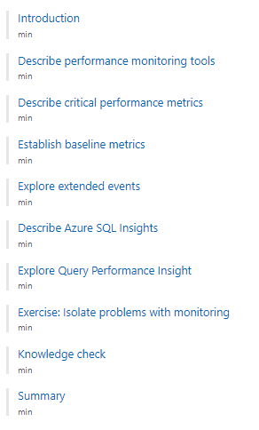

### U1. Introduction

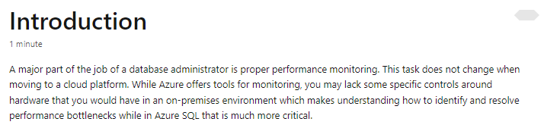

### U2. Describe performance monitoring tools

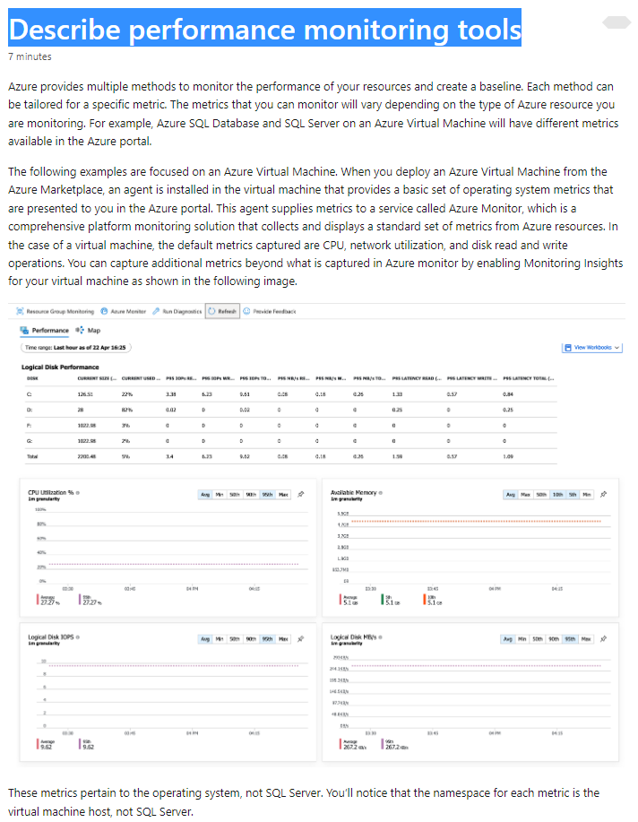

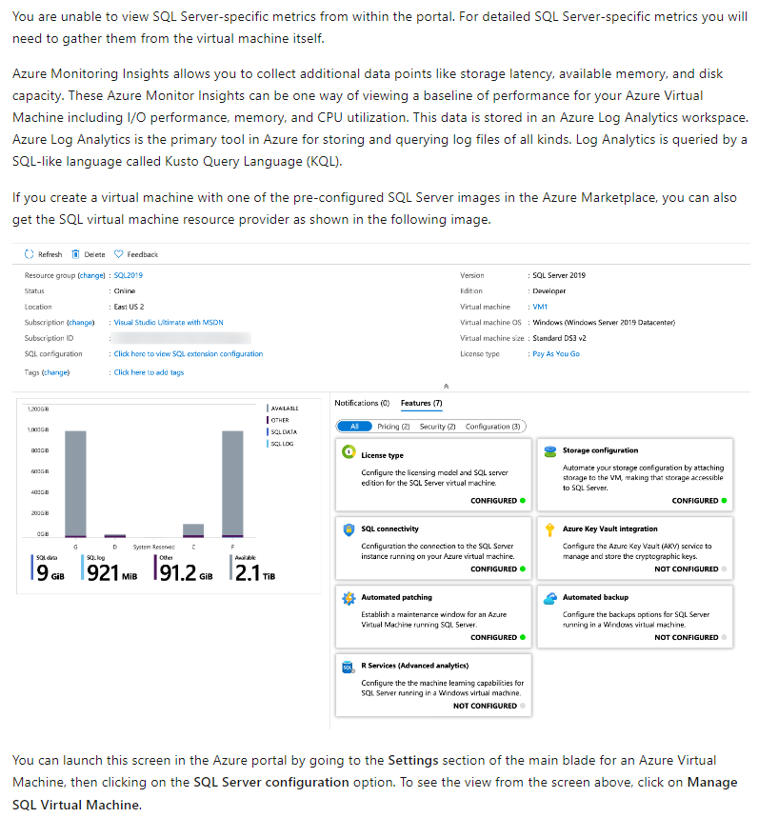

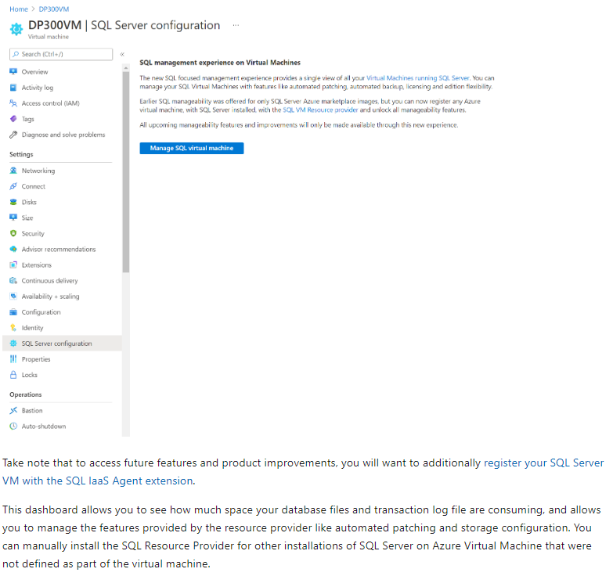

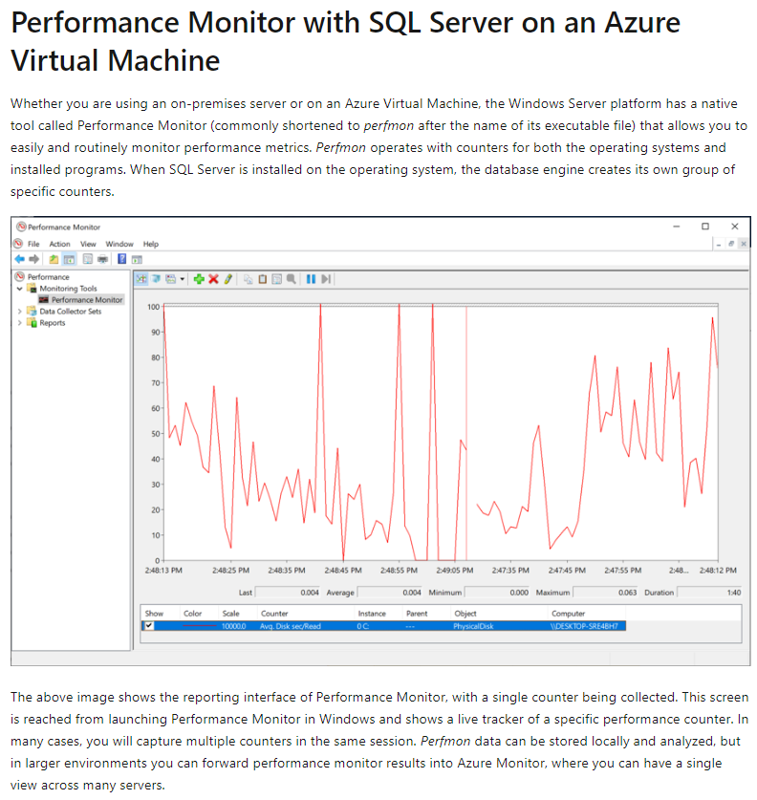

### U3. Describe critical performance metrics

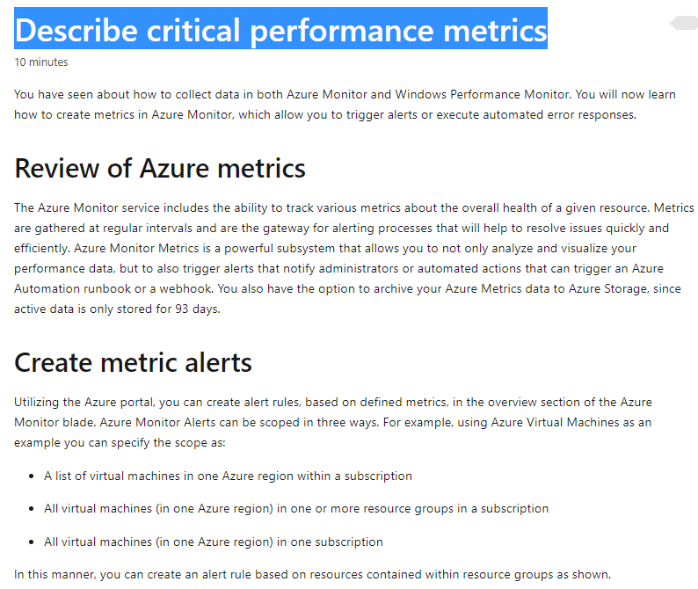

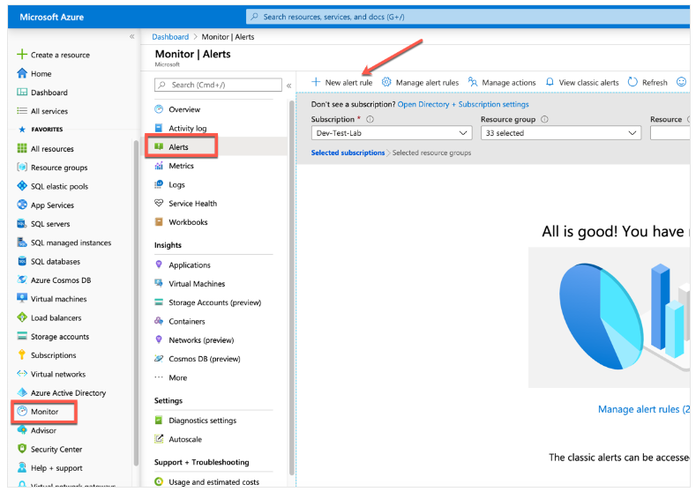

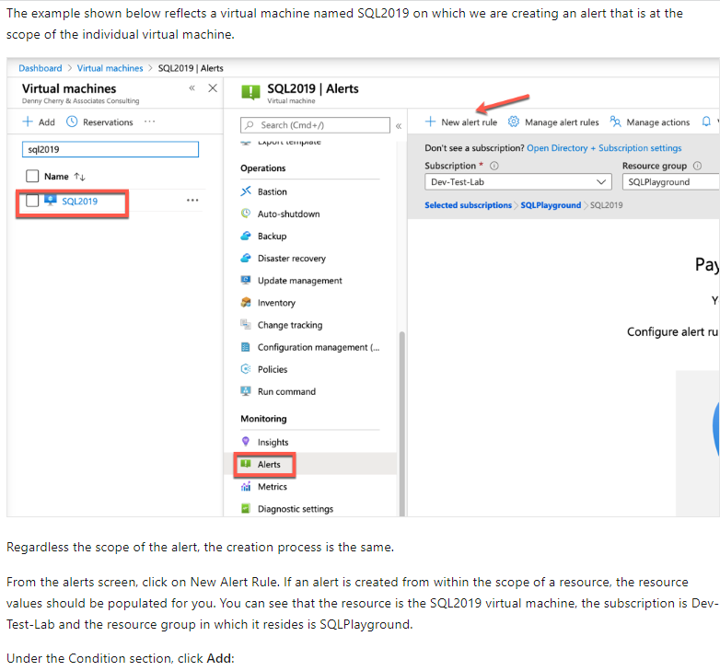

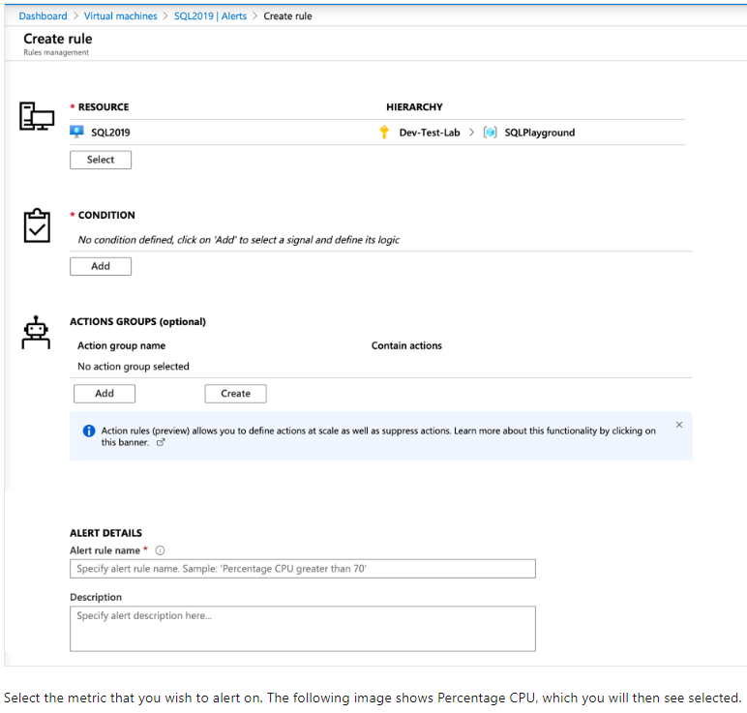

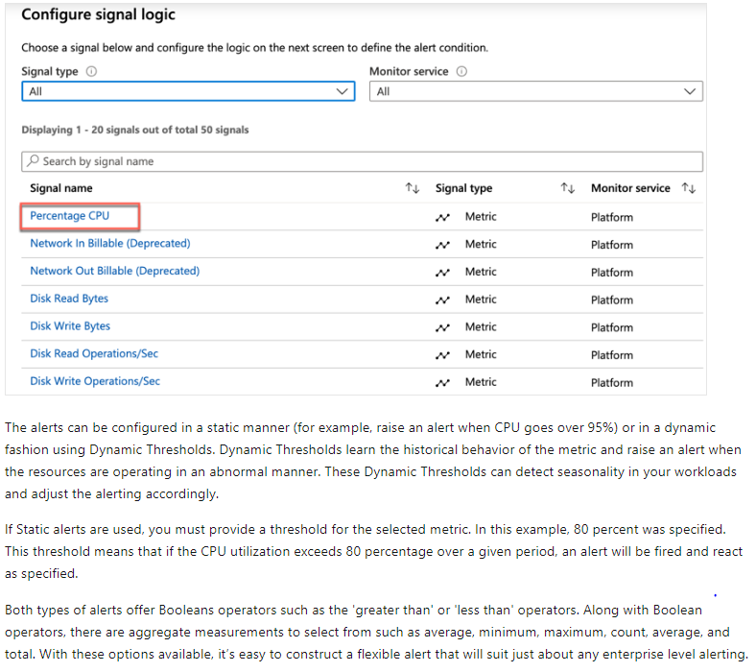

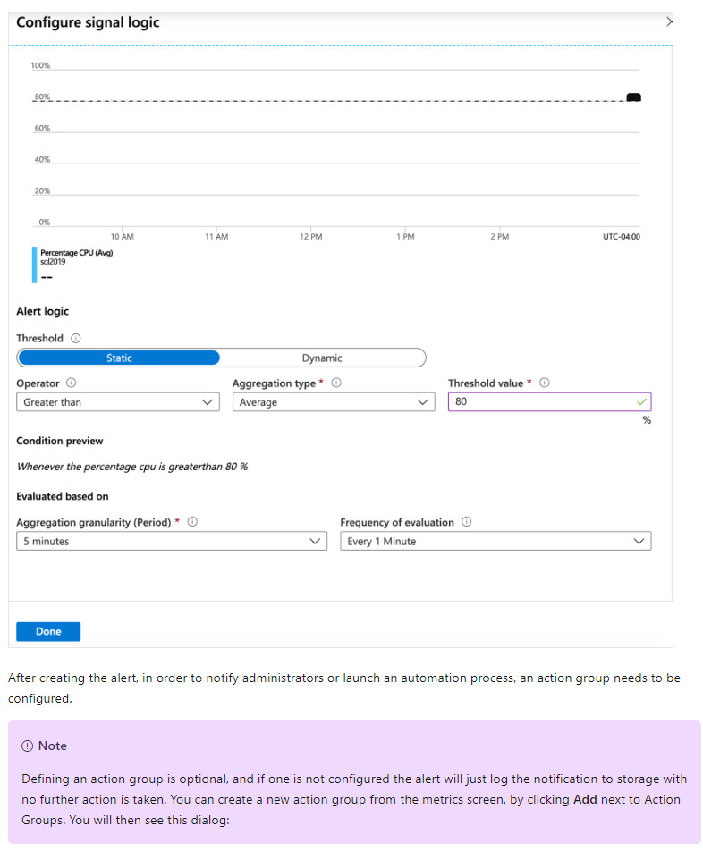

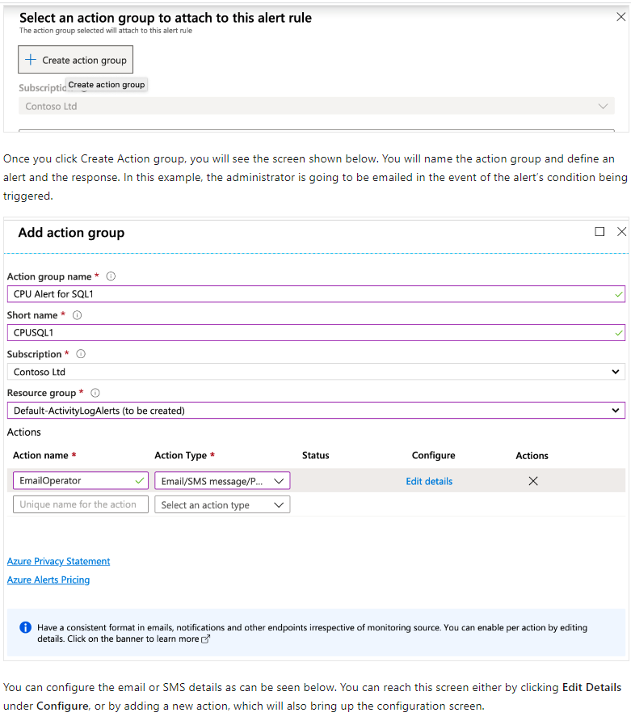

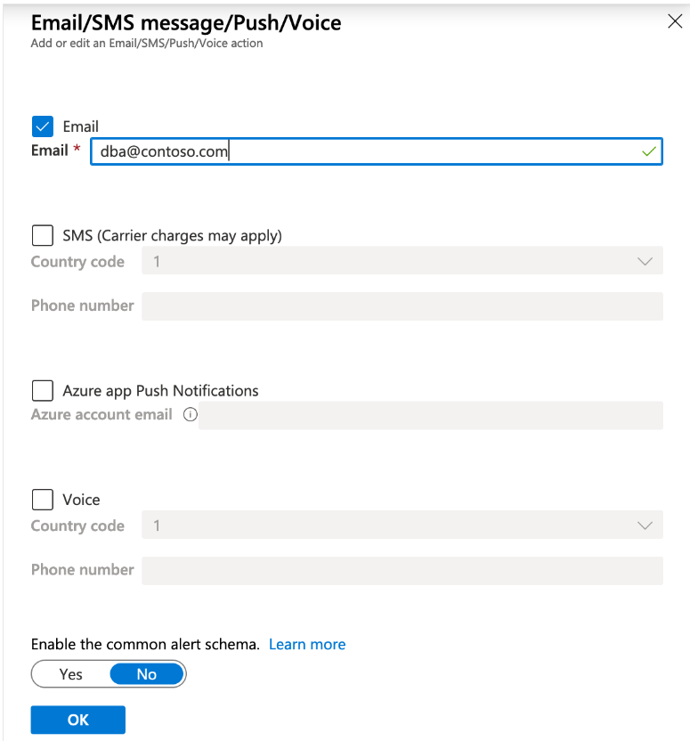

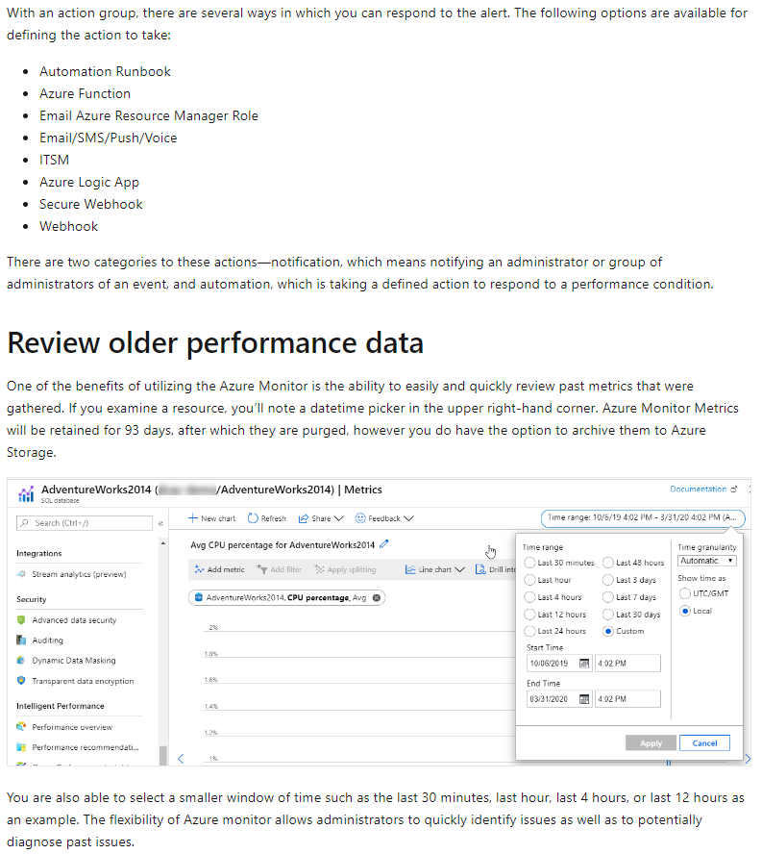

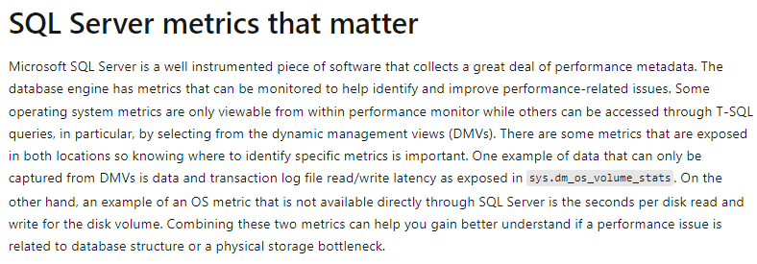

### U4. Establish baseline metrics

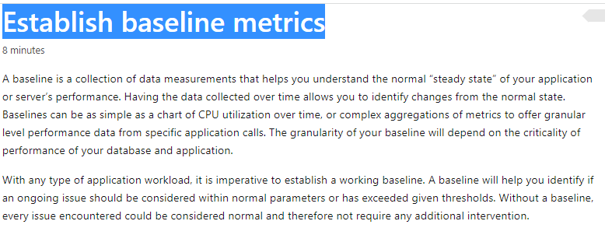

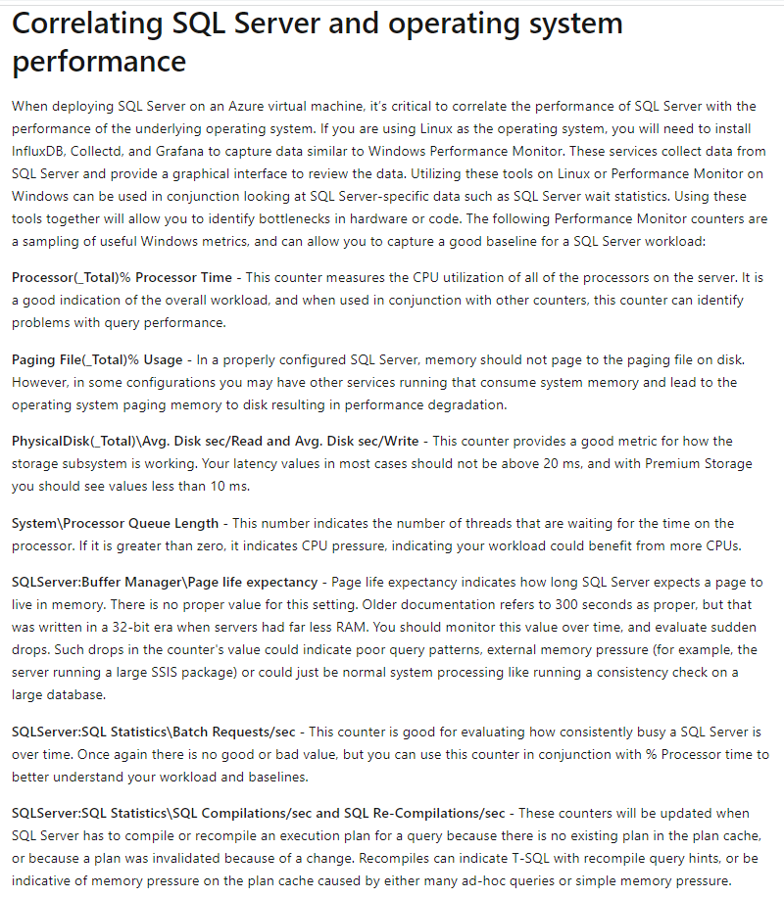

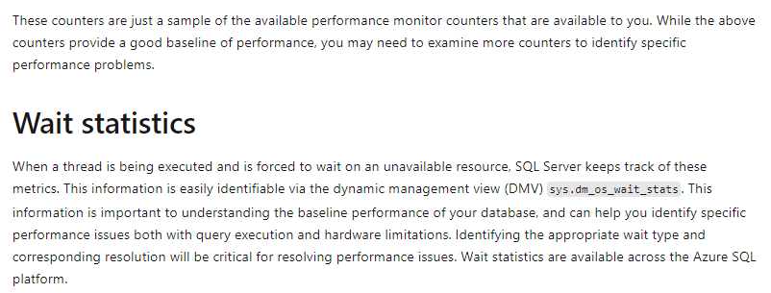

### U5. Explore extended events

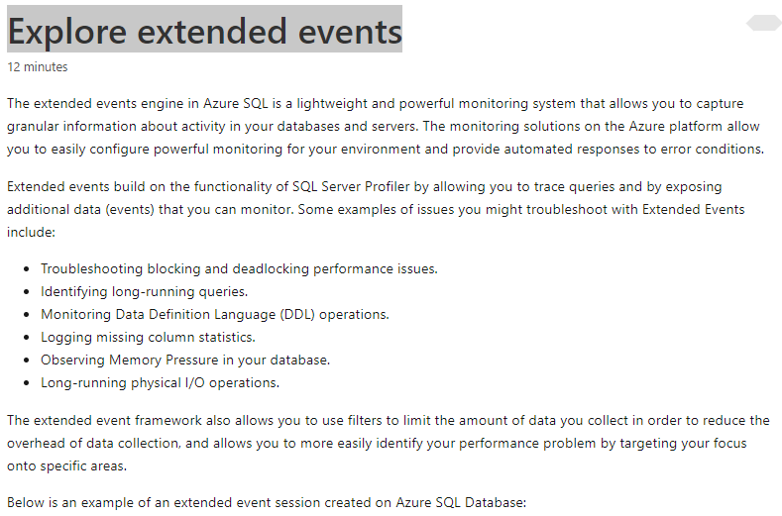

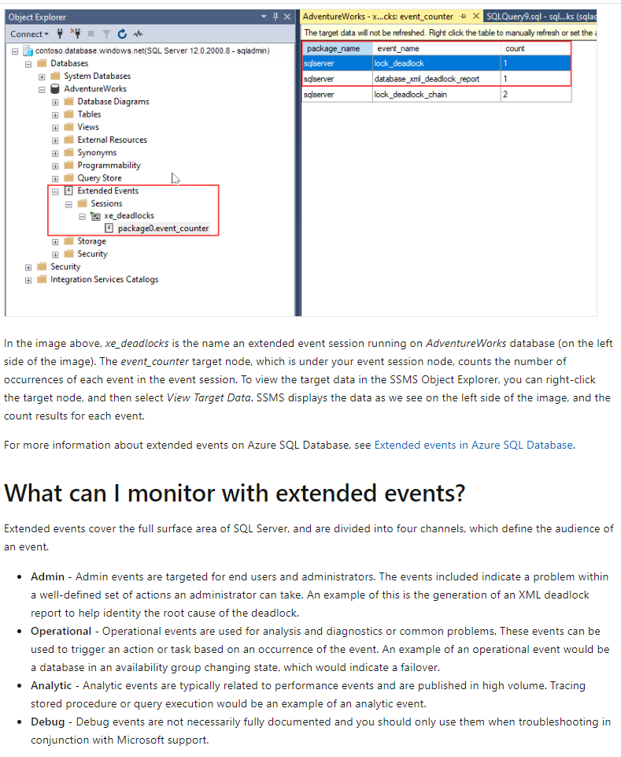

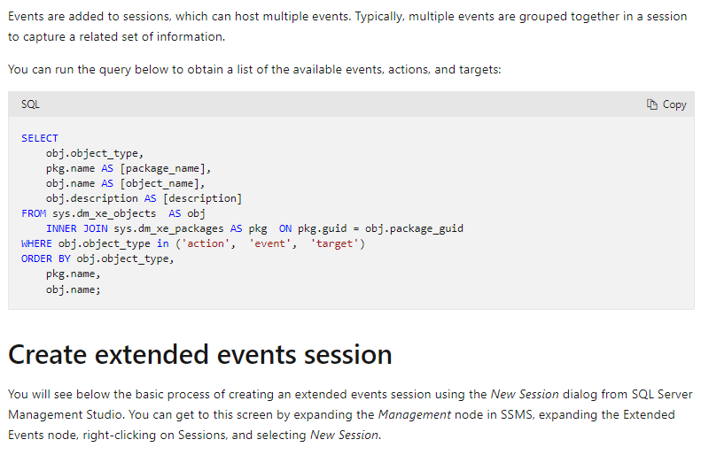

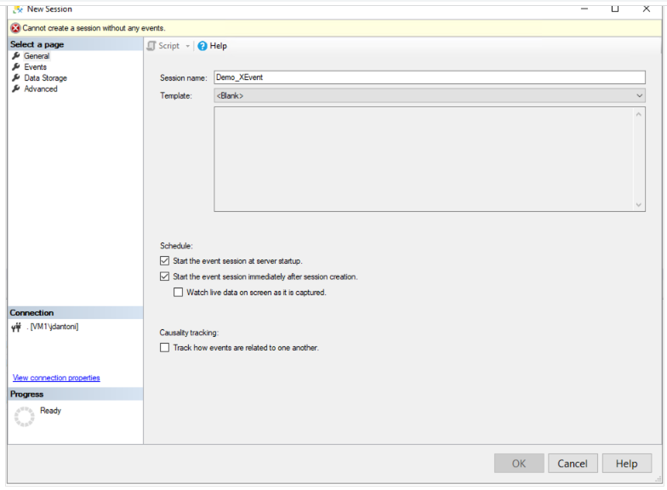

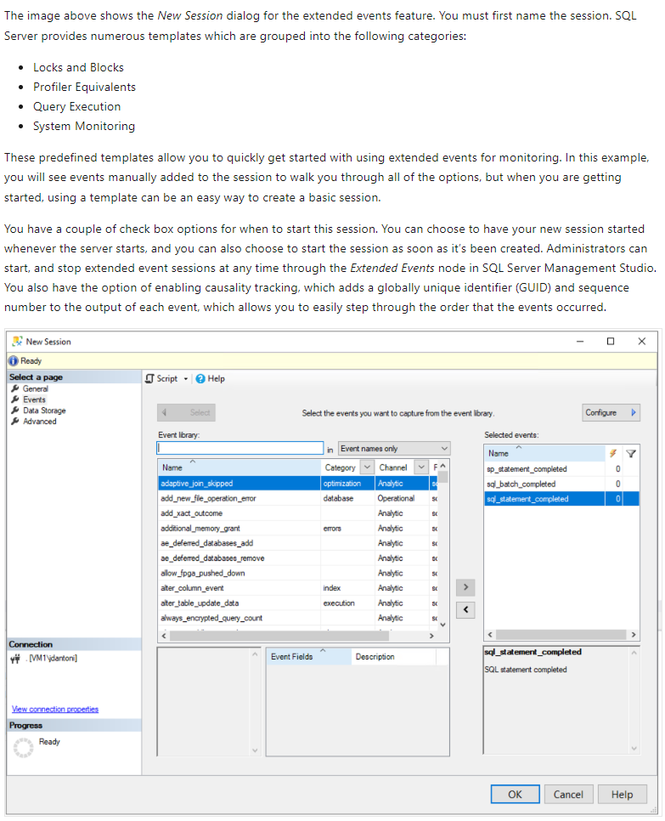

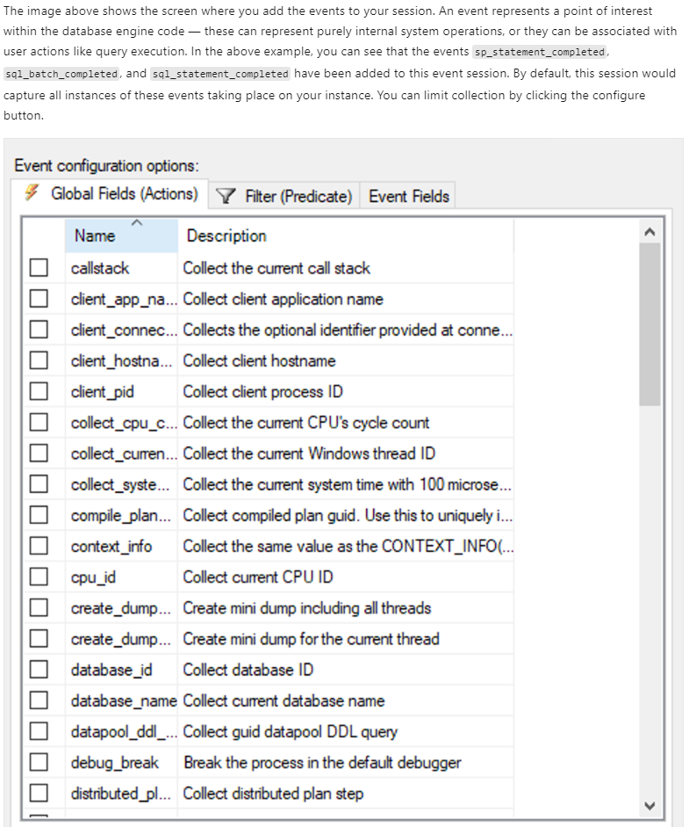

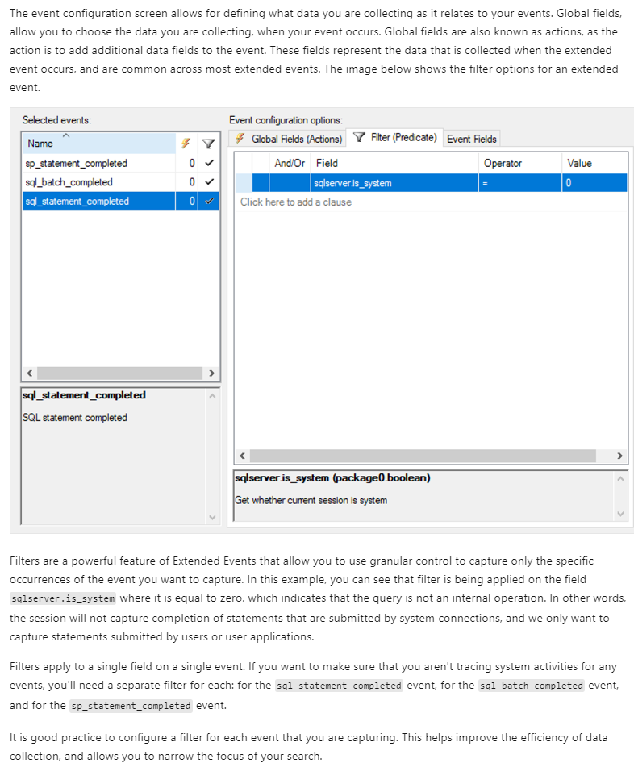

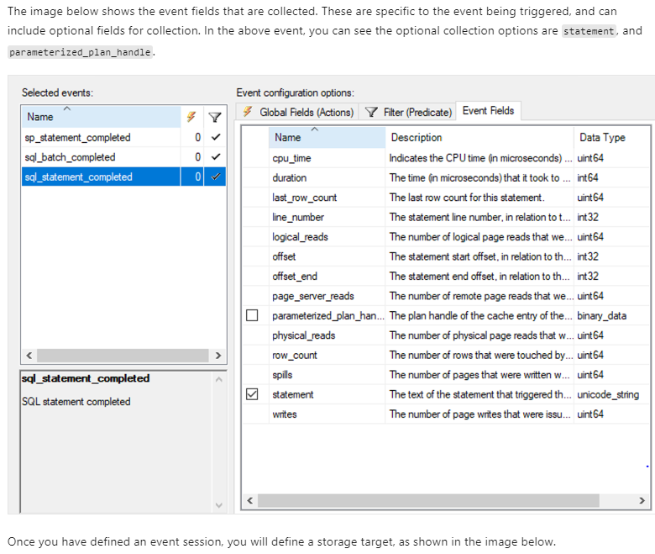

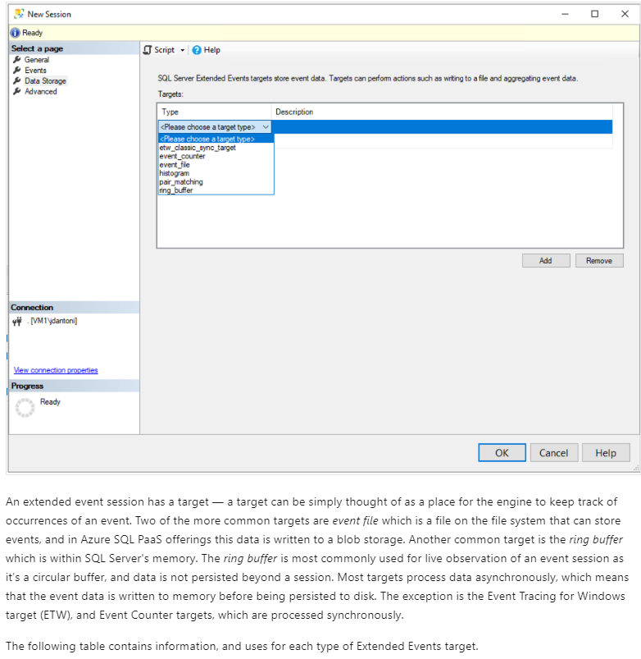 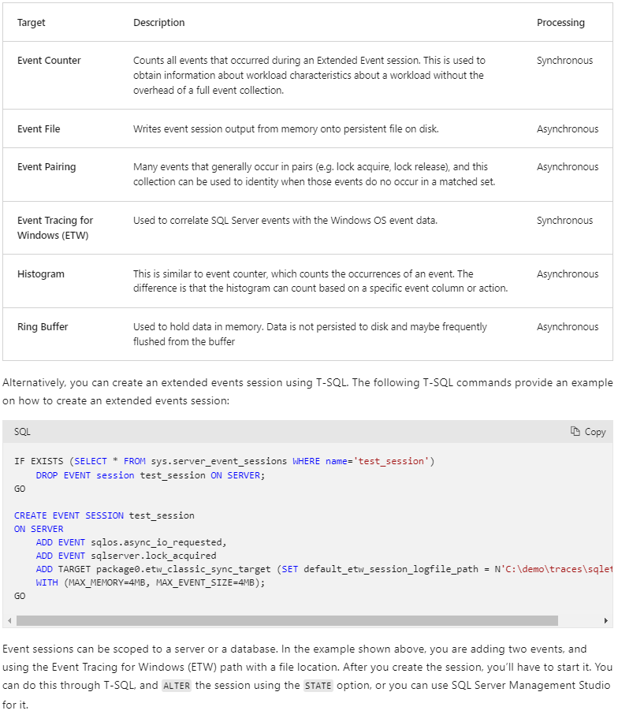

### U6. Describe Azure SQL Insights

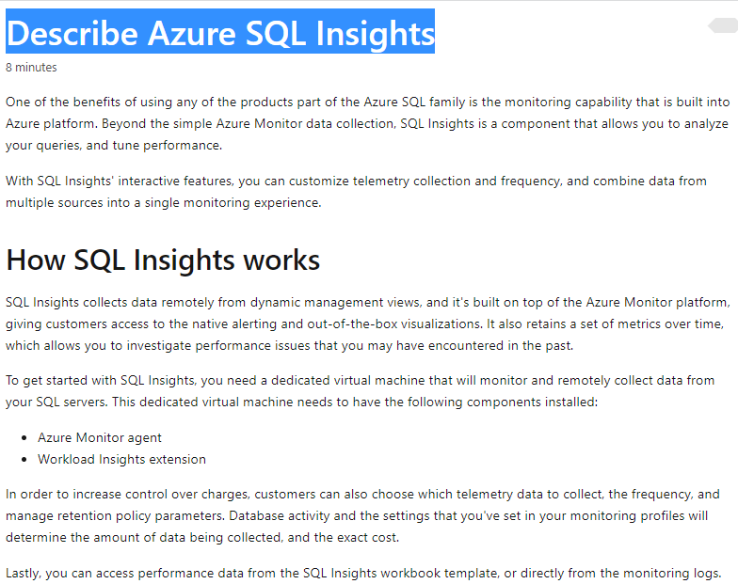

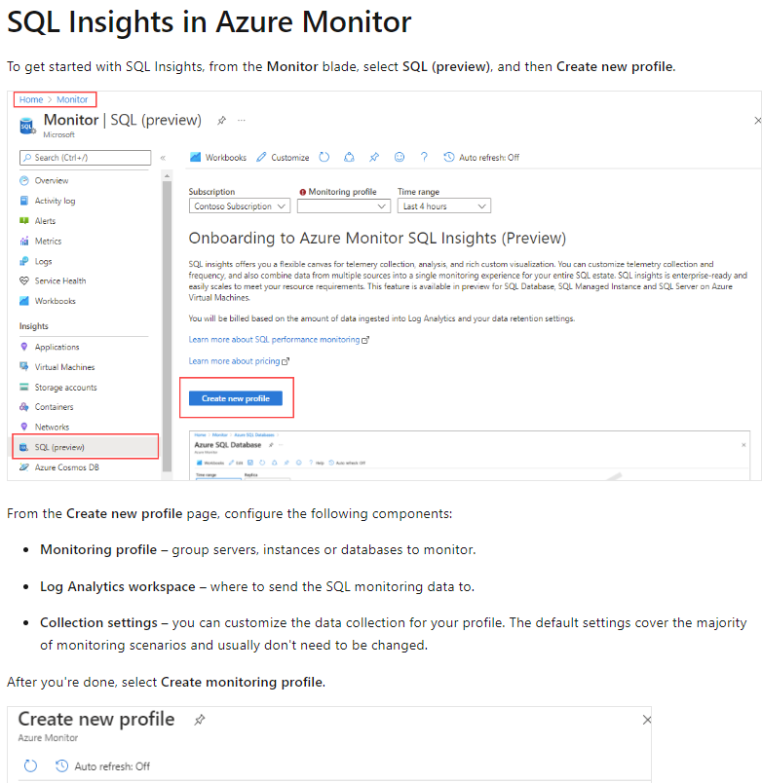

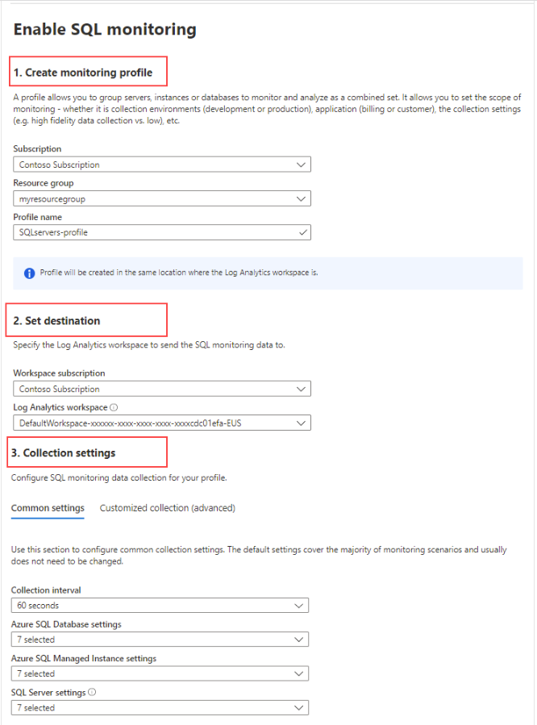

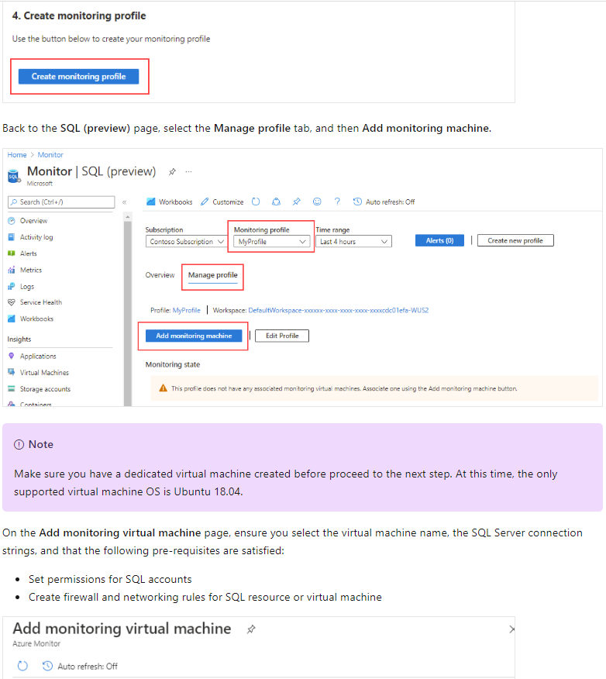

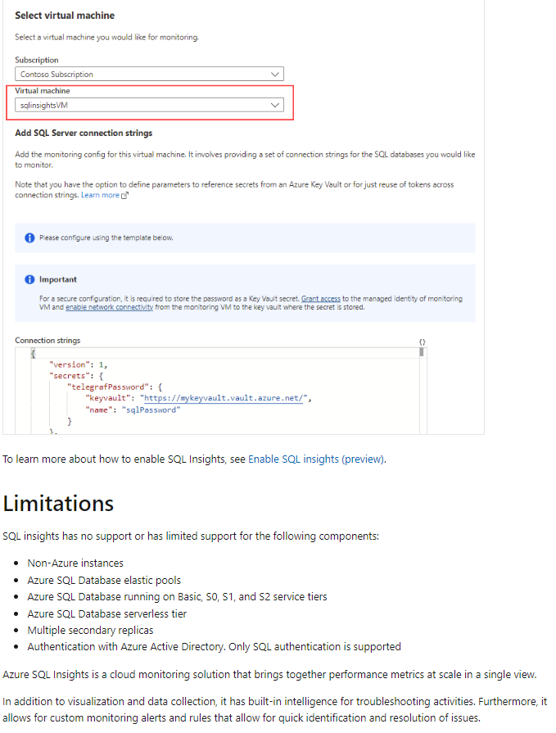

### U7. Explore Query Performance Insight

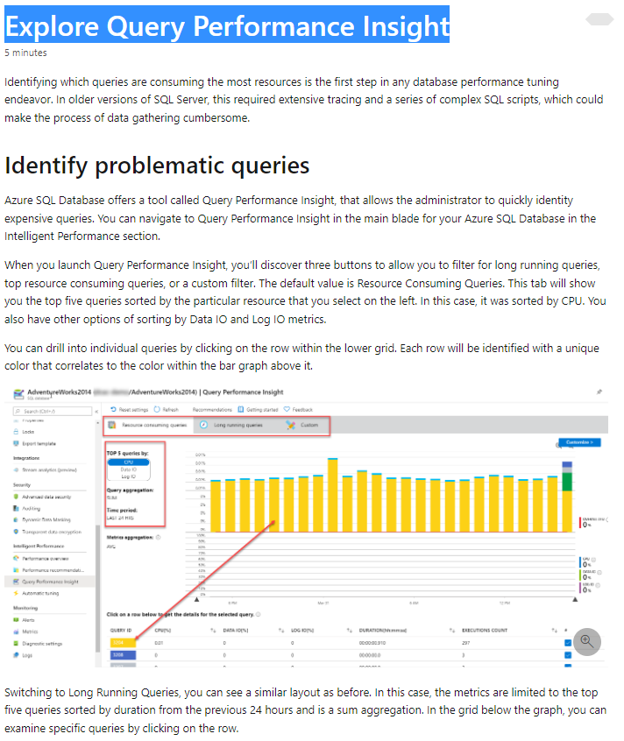

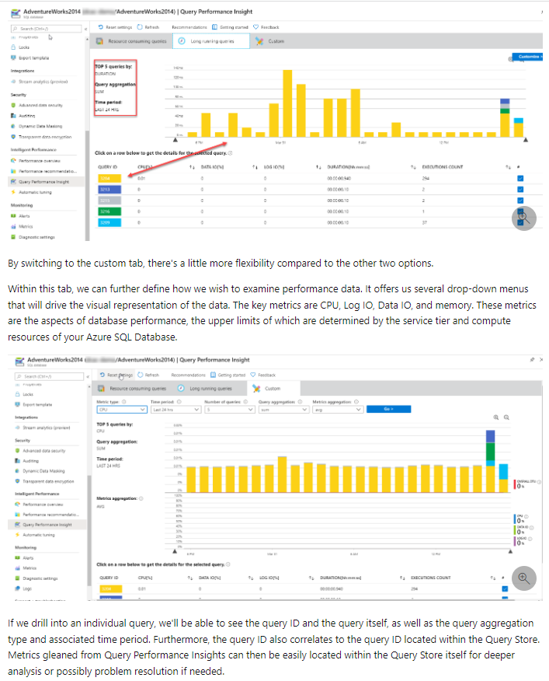

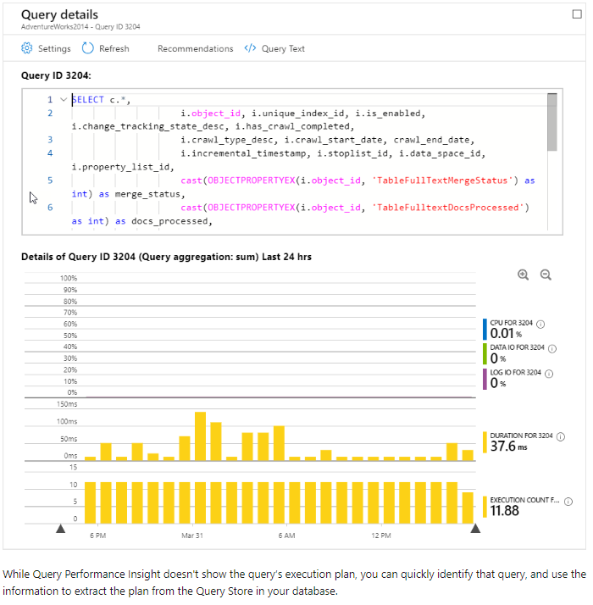

### U8. Knowledge check

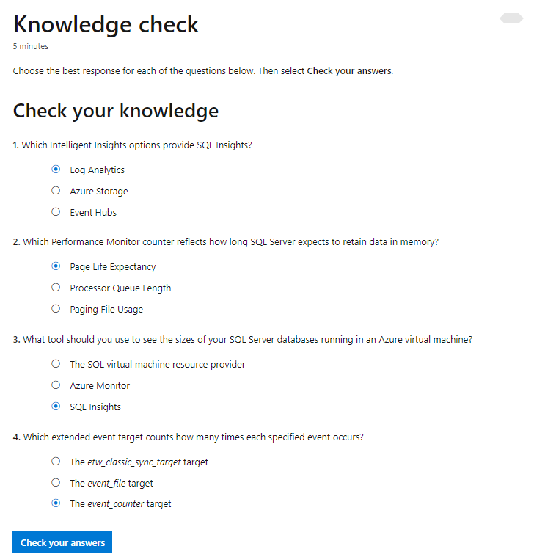

## M2. Configure SQL Server resources for optimal performance

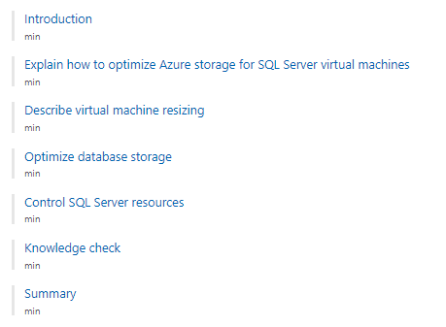

### U1. Introduction

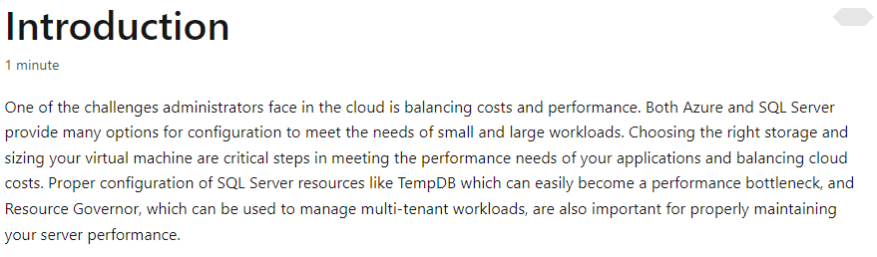

### U2. Explain how to optimize Azure storage for SQL Server virtual machines

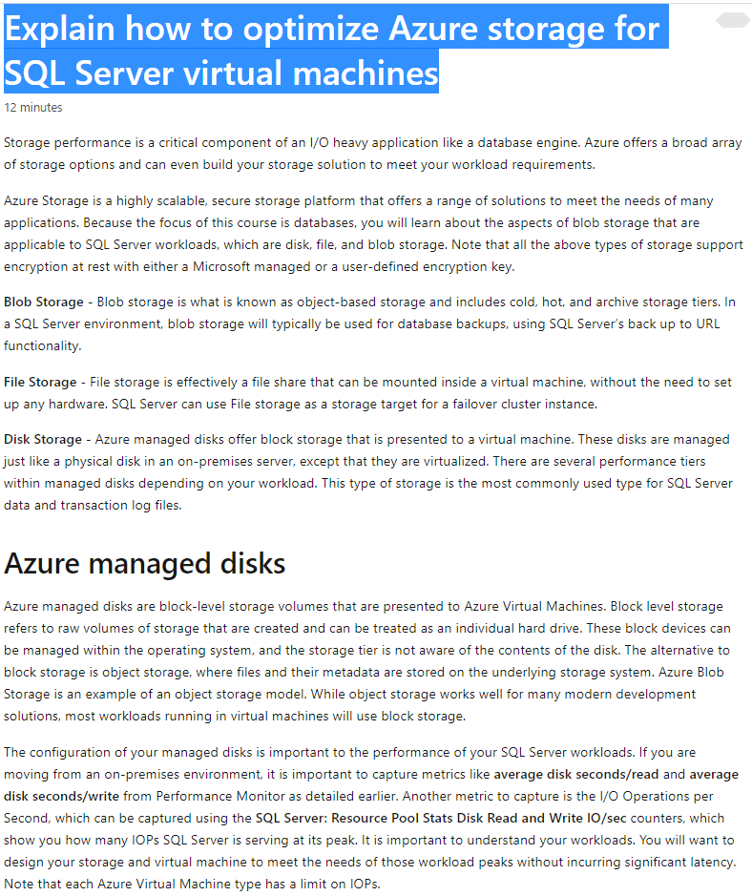

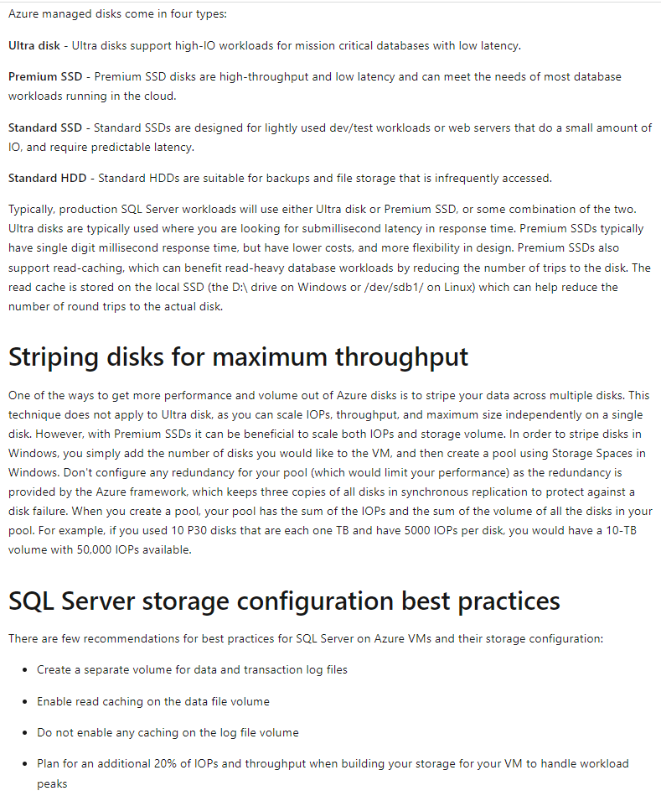

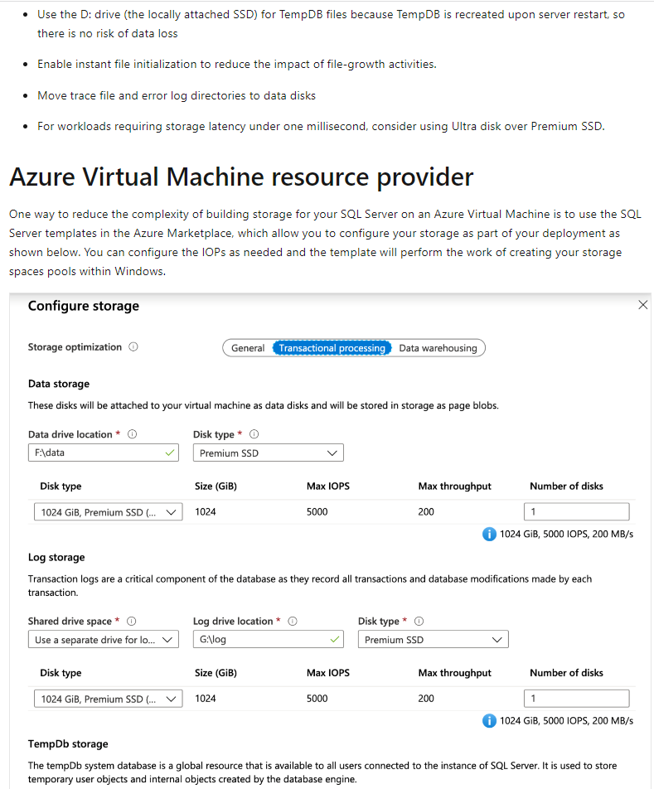



### U3. Describe virtual machine resizing

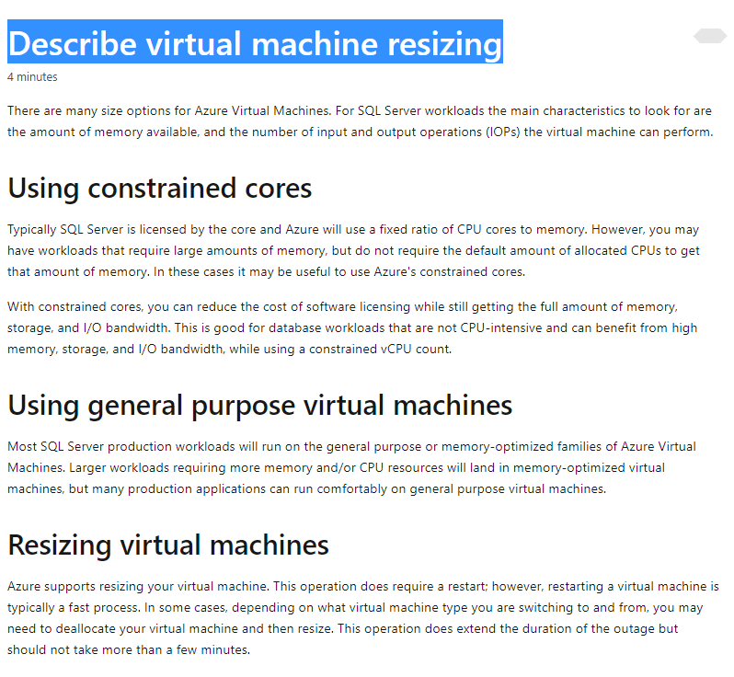

### U4. Optimize database storage

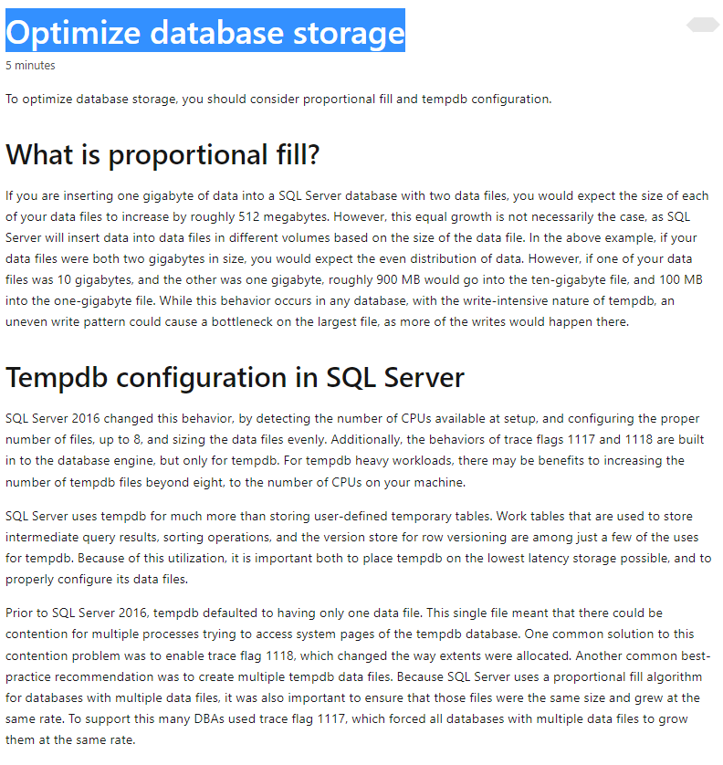

### U5. Control SQL Server resources

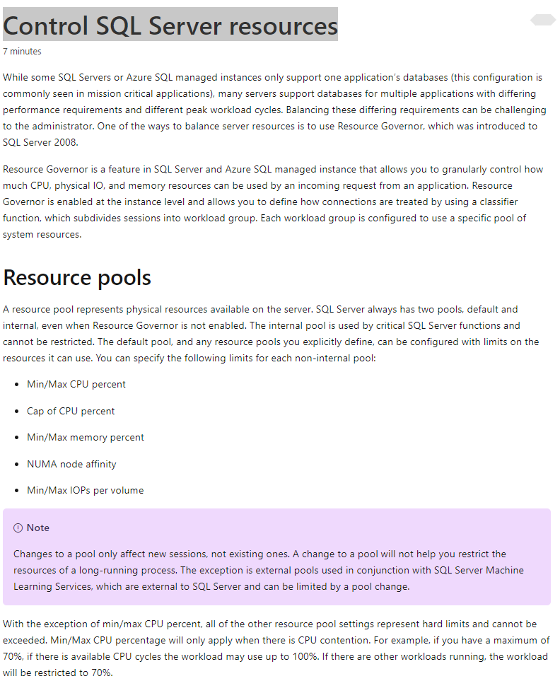

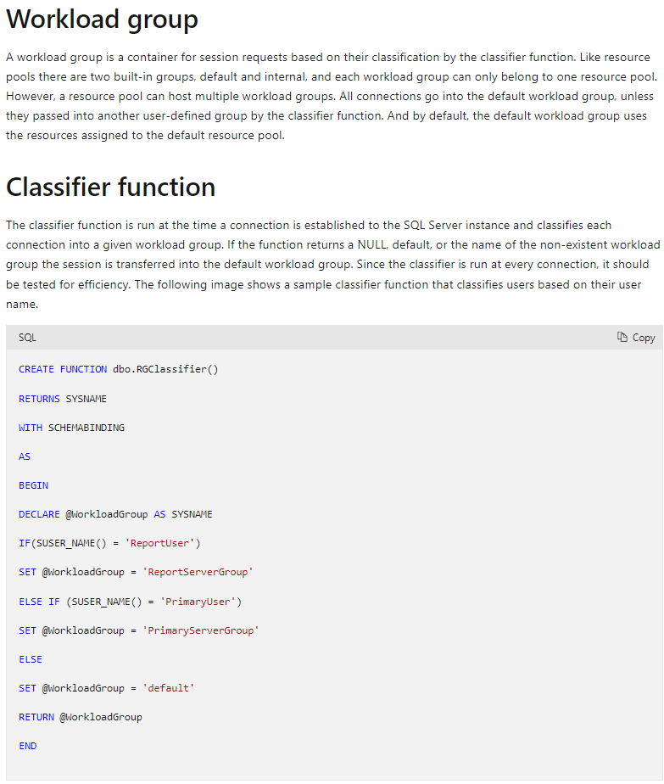

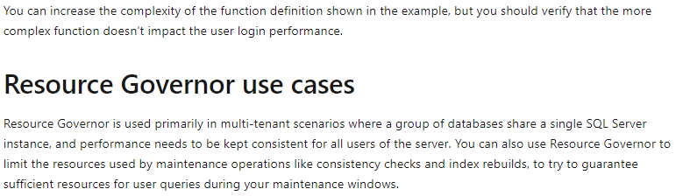

### U6. Knowledge check

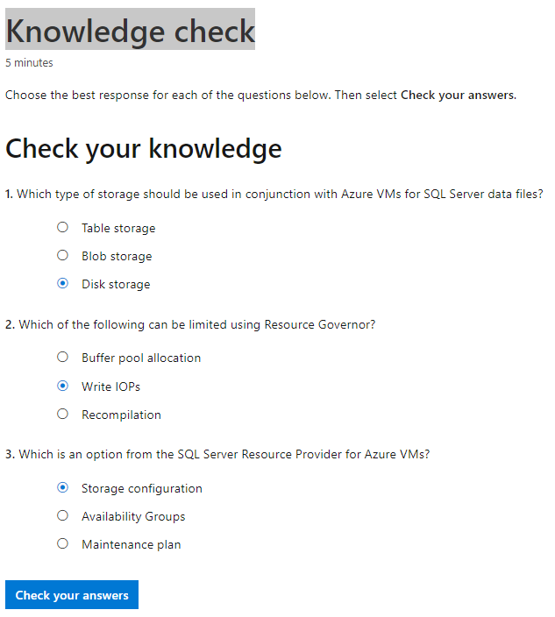

## M3. Configure databases for optimal performance

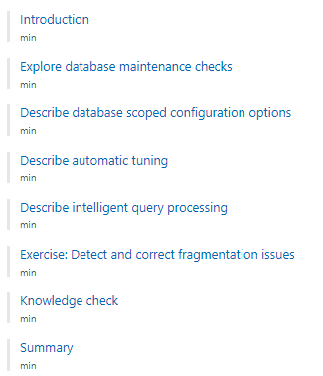

### U1. Introduction

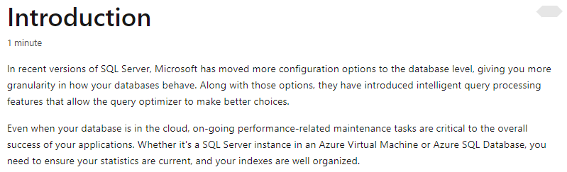

### U2. Explore database maintenance checks

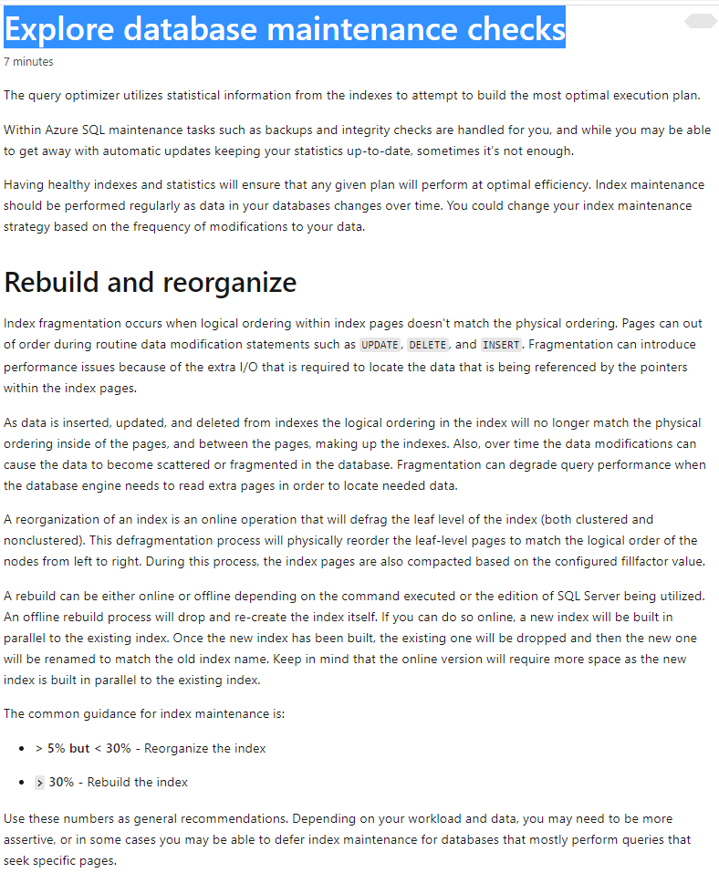

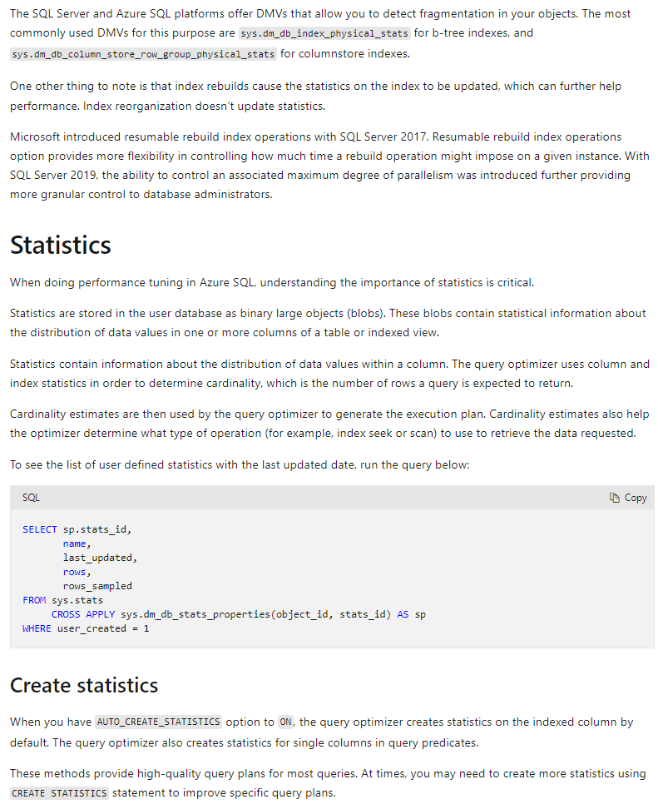

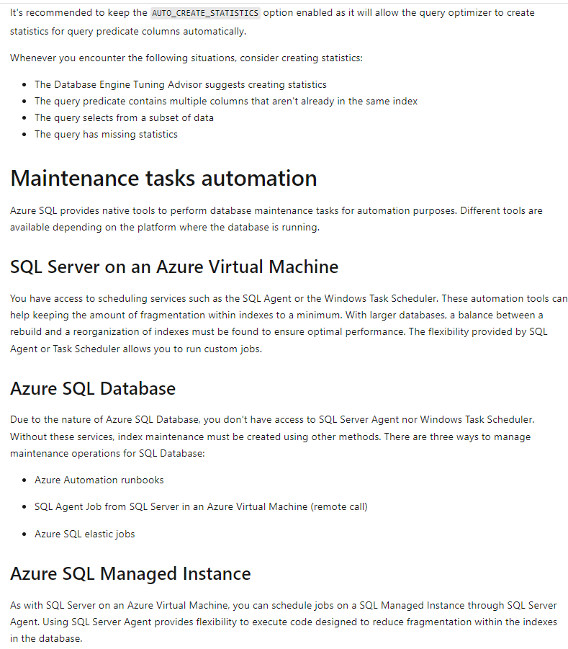

### U3. Describe database scoped configuration options

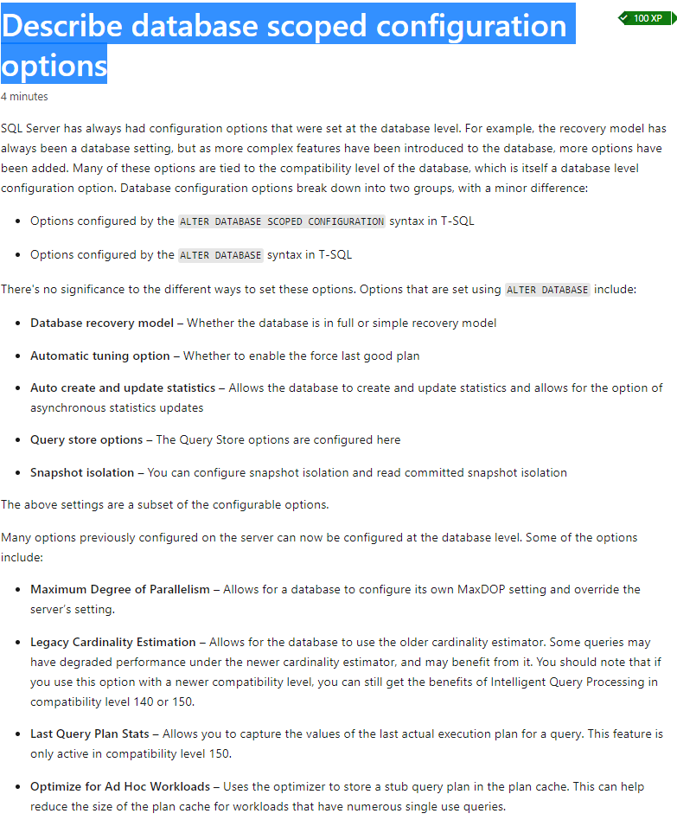

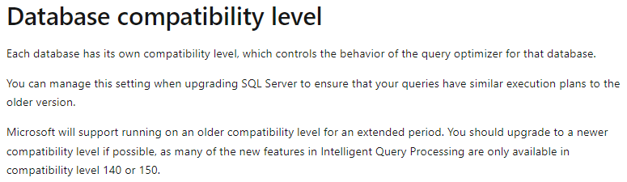

### U4. Describe automatic tuning

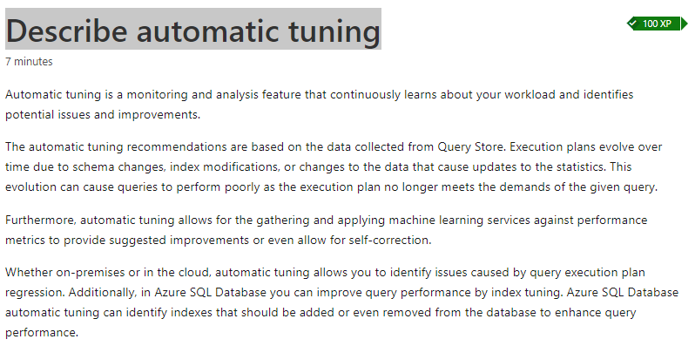

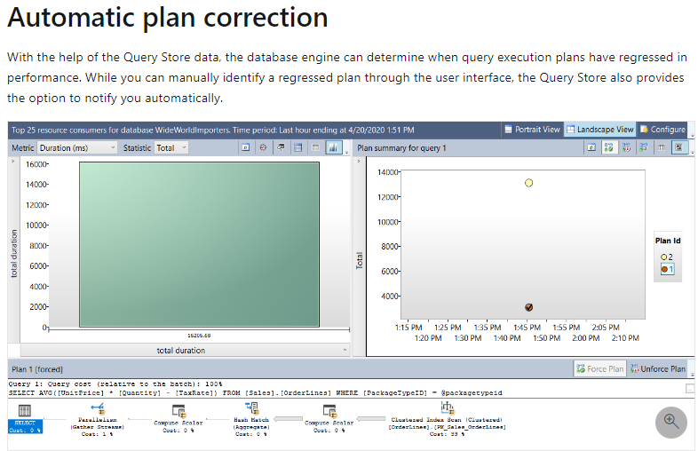

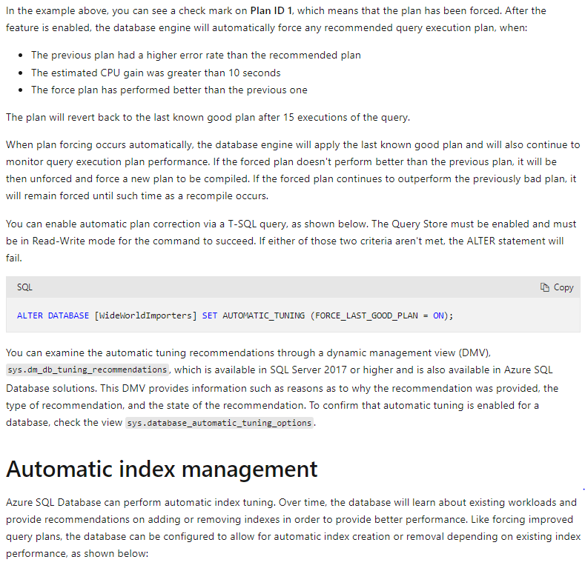

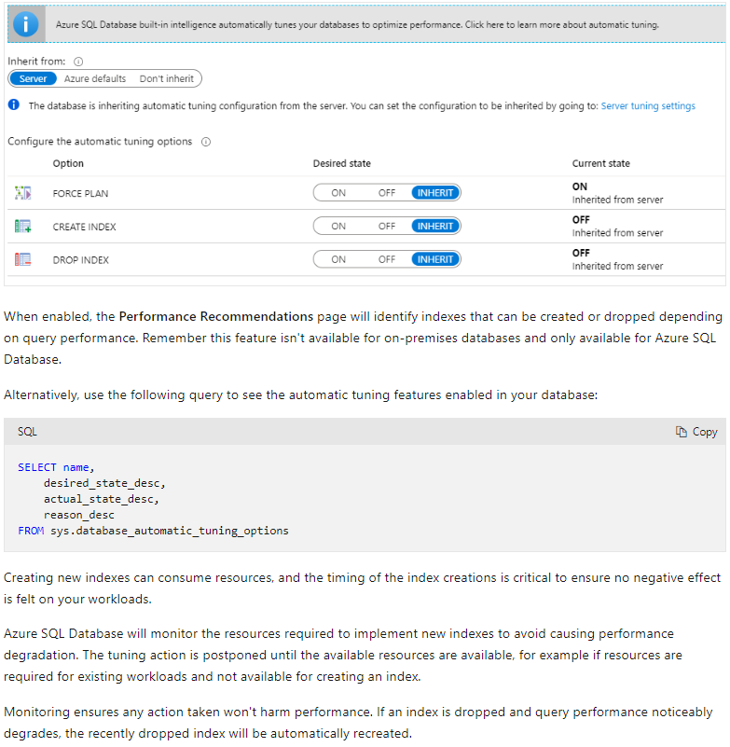

### U5. Describe intelligent query processing

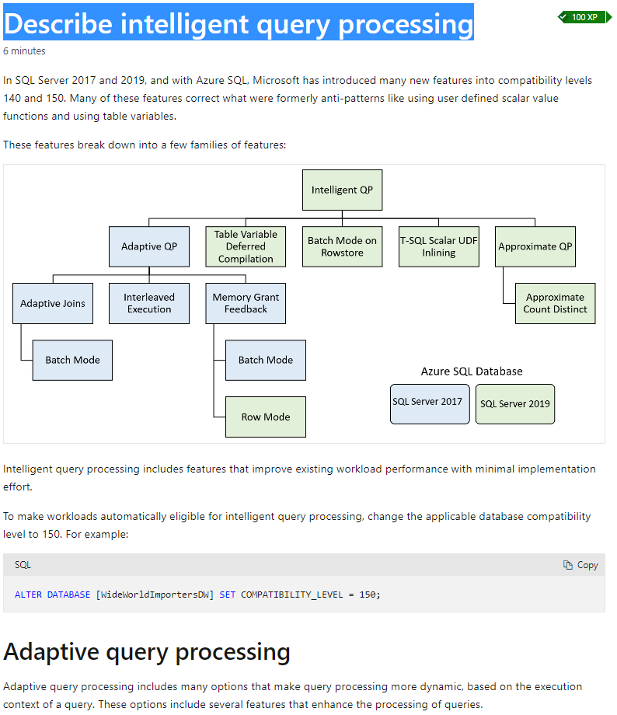

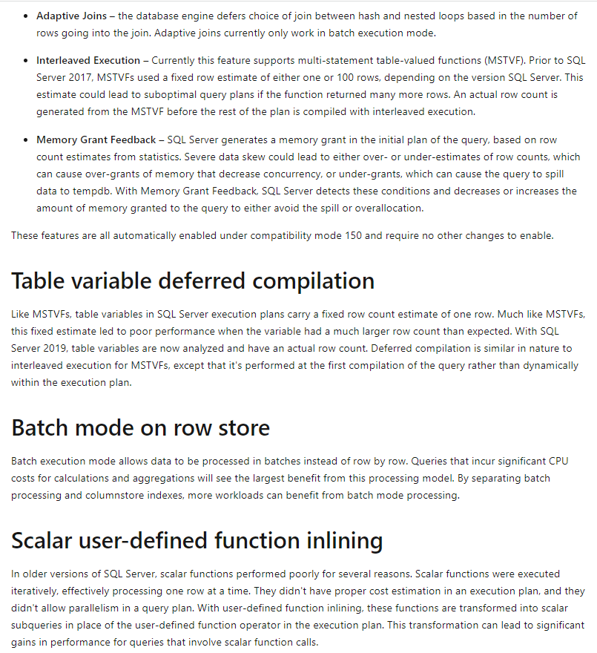

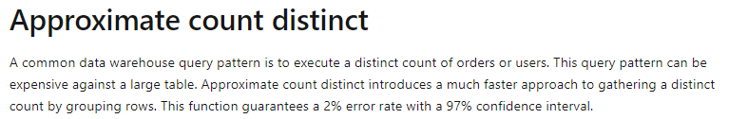

### U6. Knowledge check

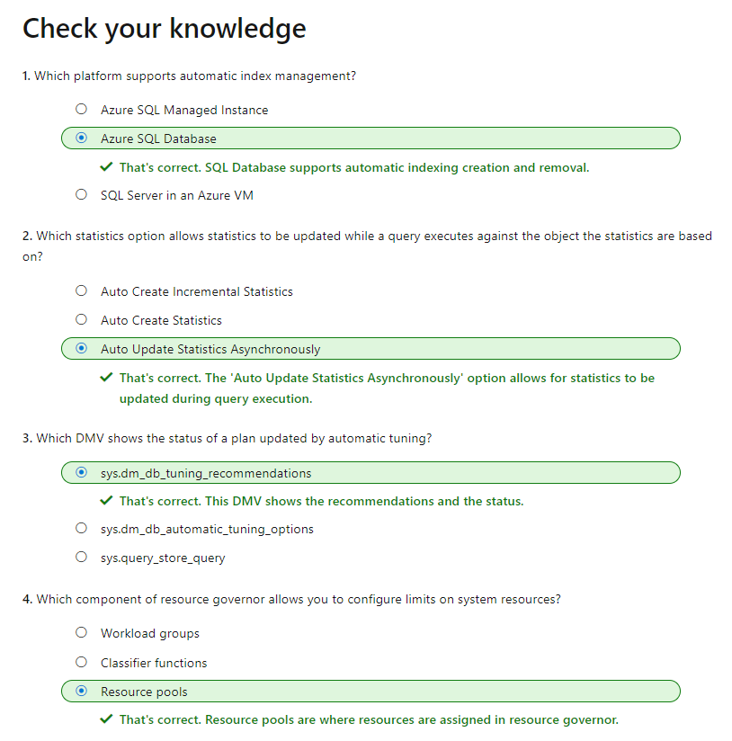

# LP5. Optimize query performance in Azure SQL

## M1. Explore query performance optimization

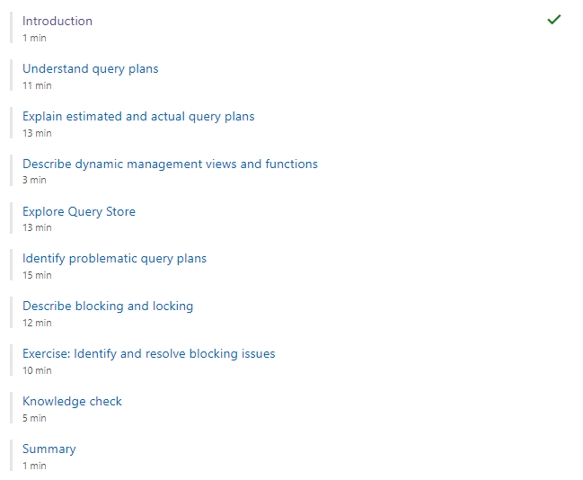

### U1. Introduction

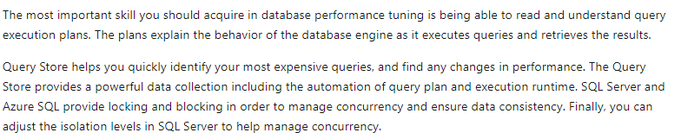

### U2. Understand query plans

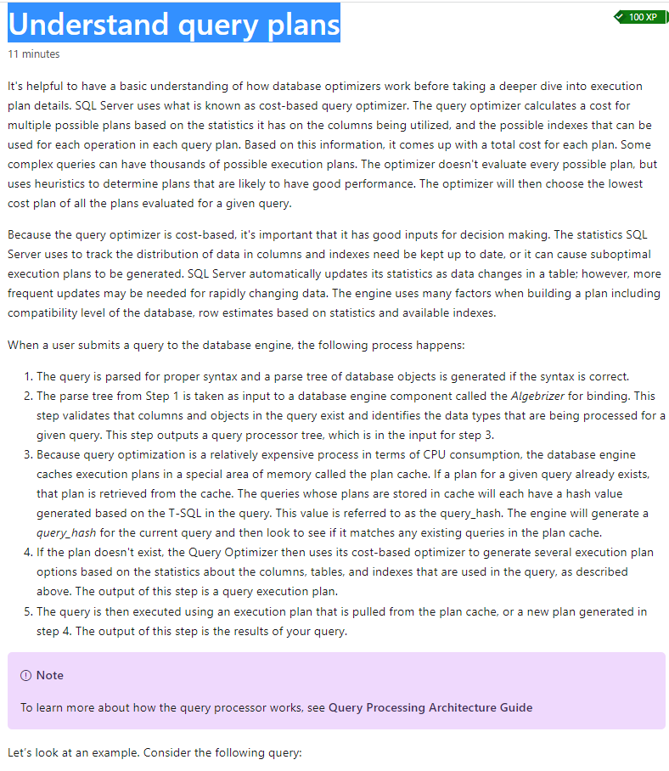

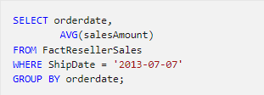

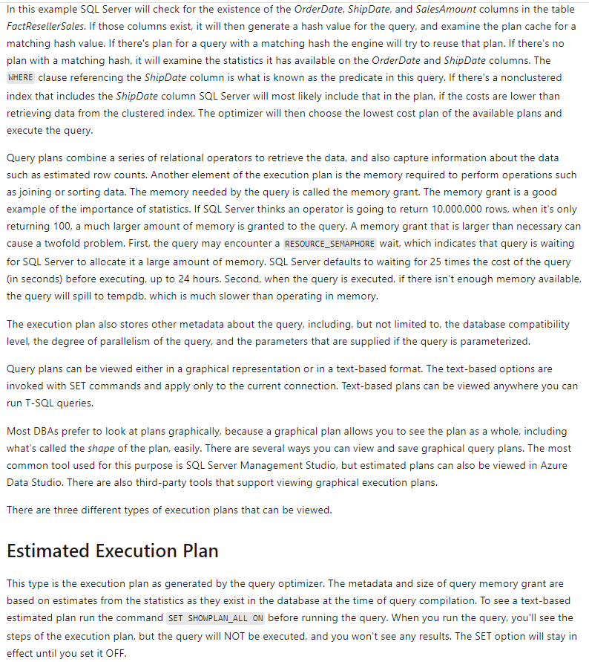

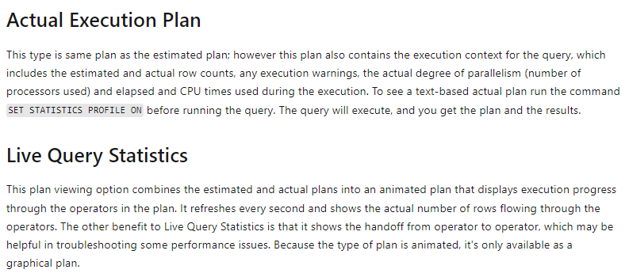

### U3. Explain estimated and actual query plans

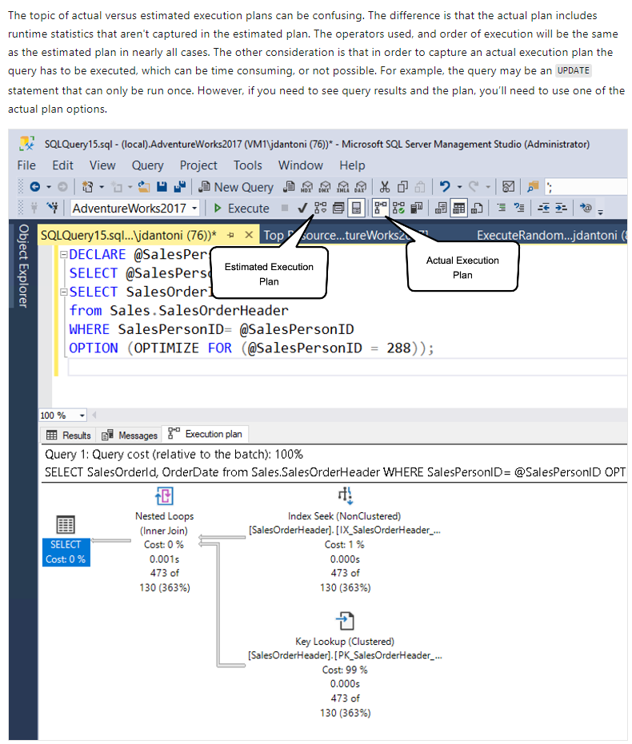

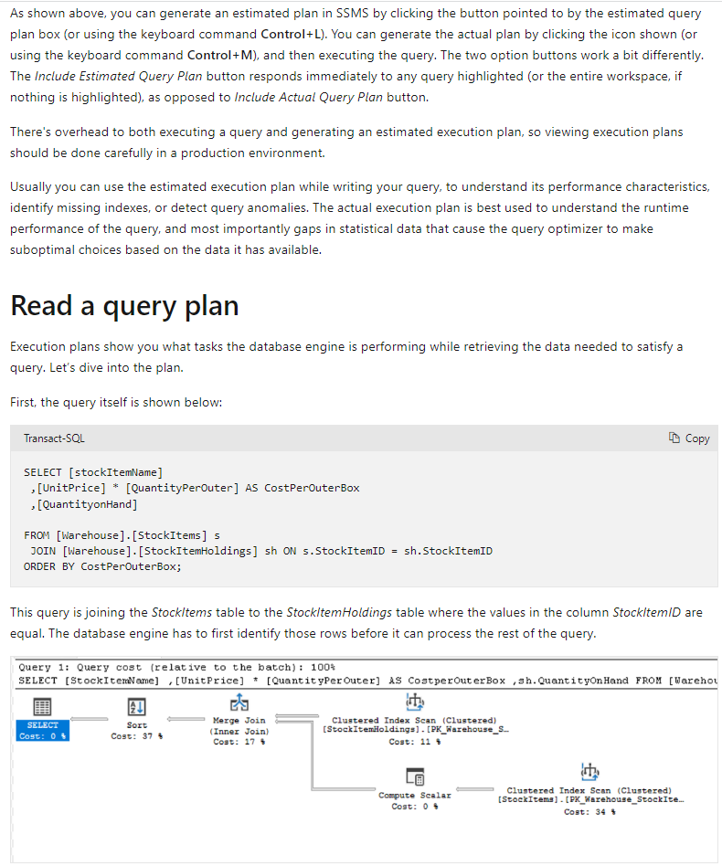

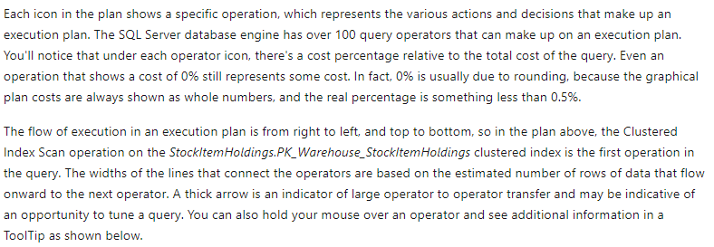

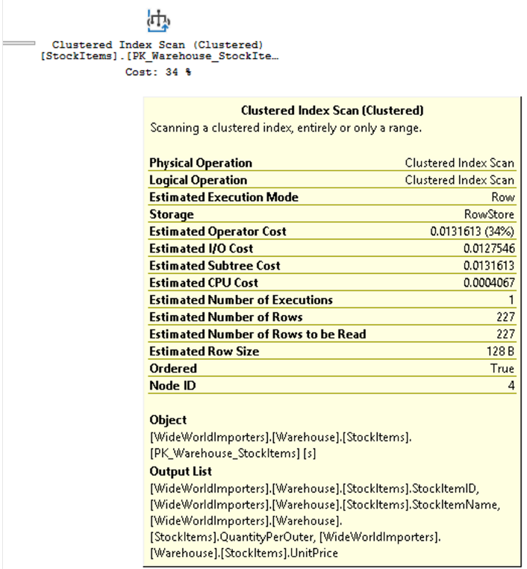

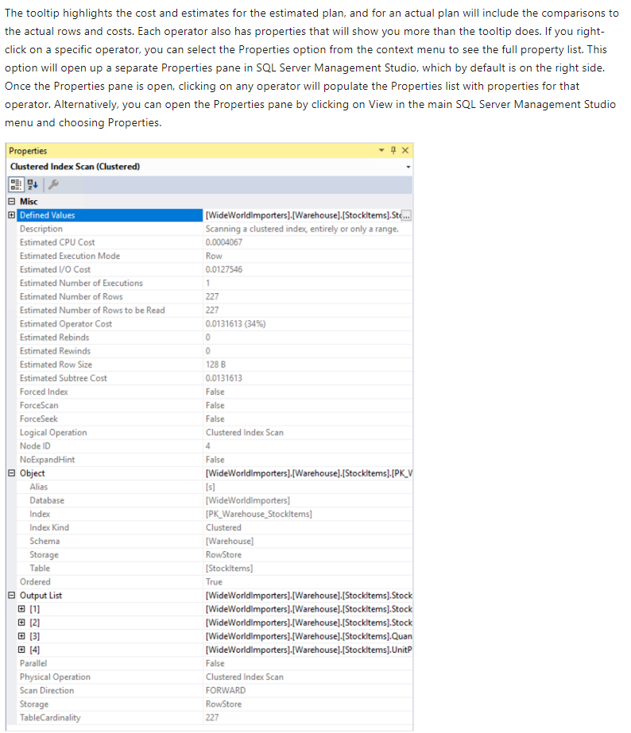

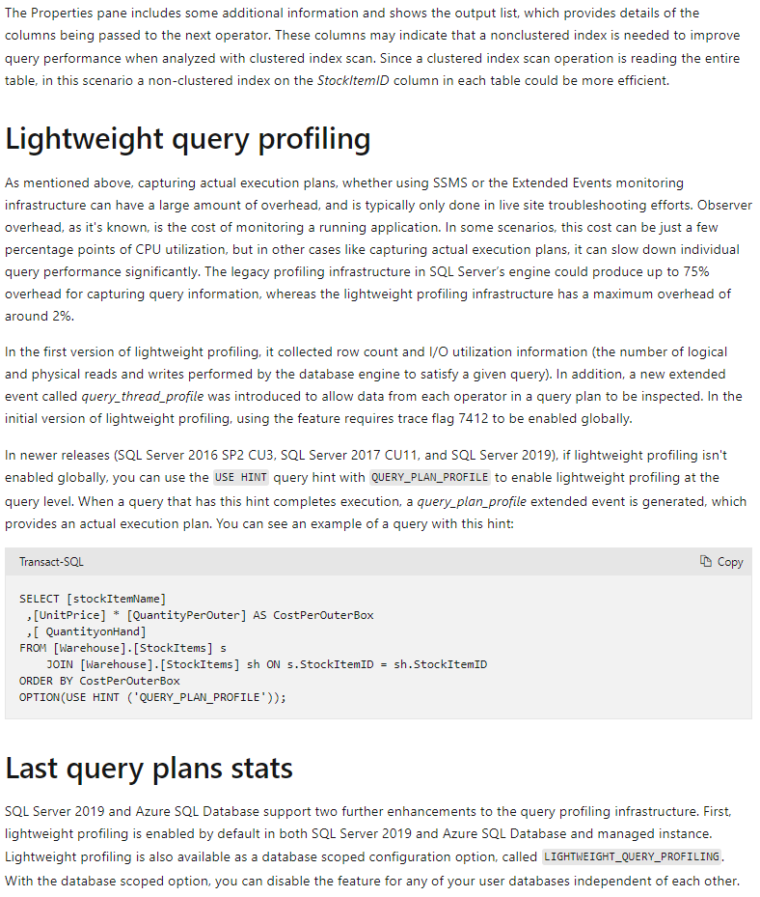

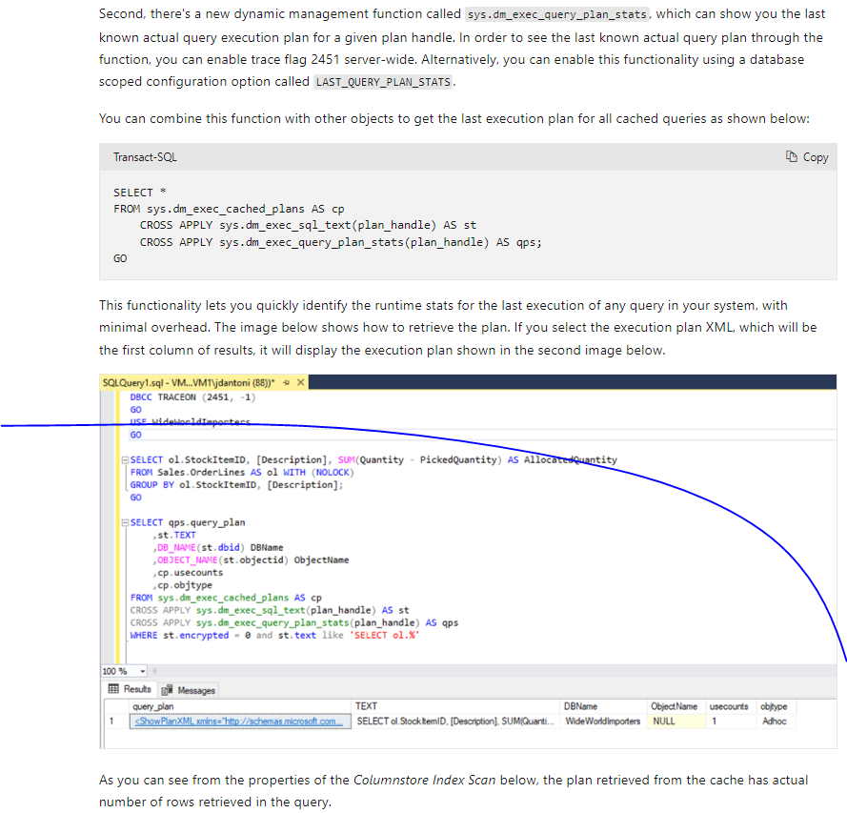

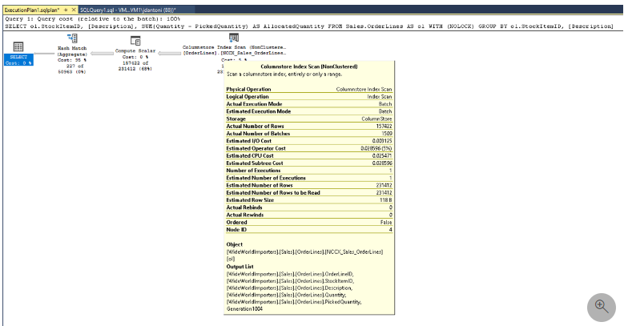

### U4. Describe dynamic management views and functions

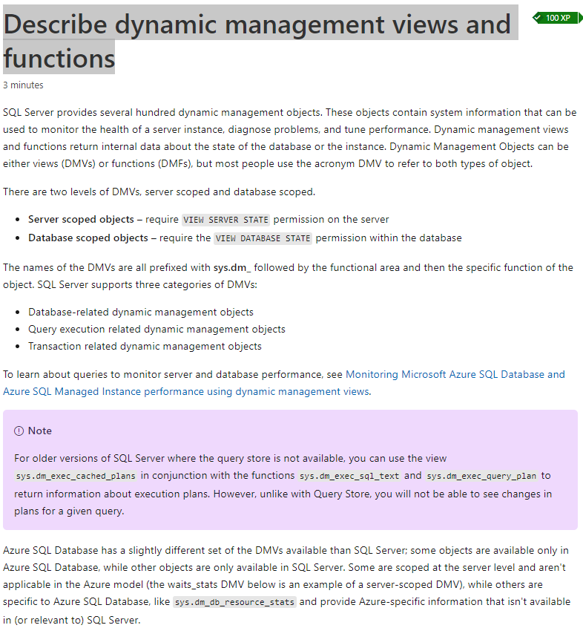

### U5. Explore Query Store

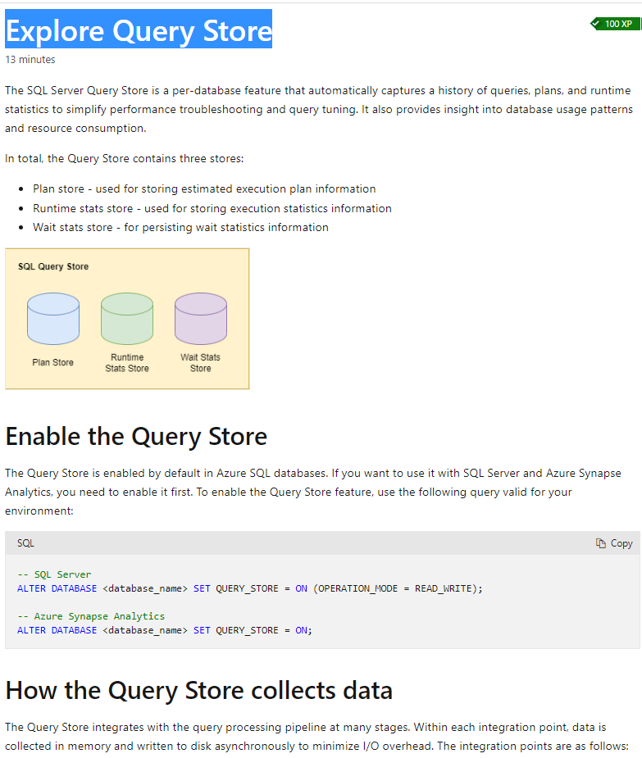

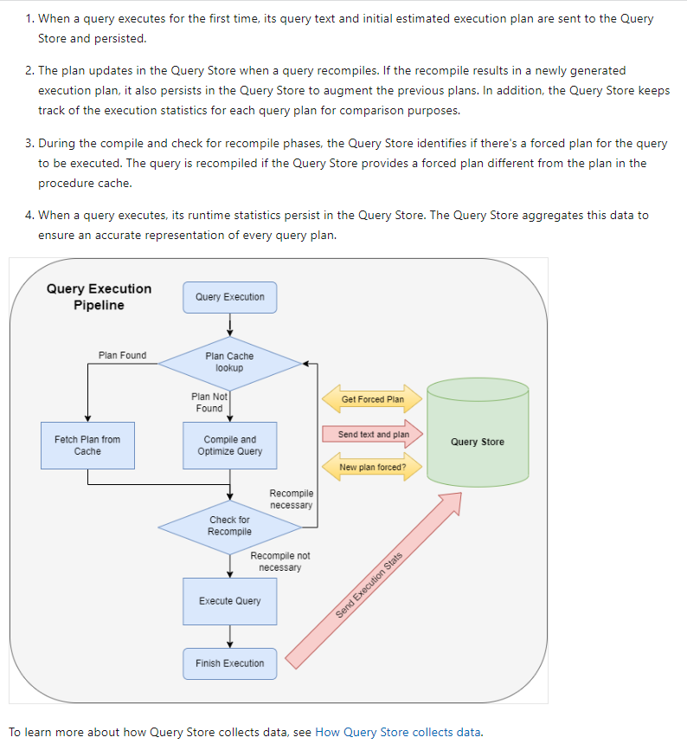

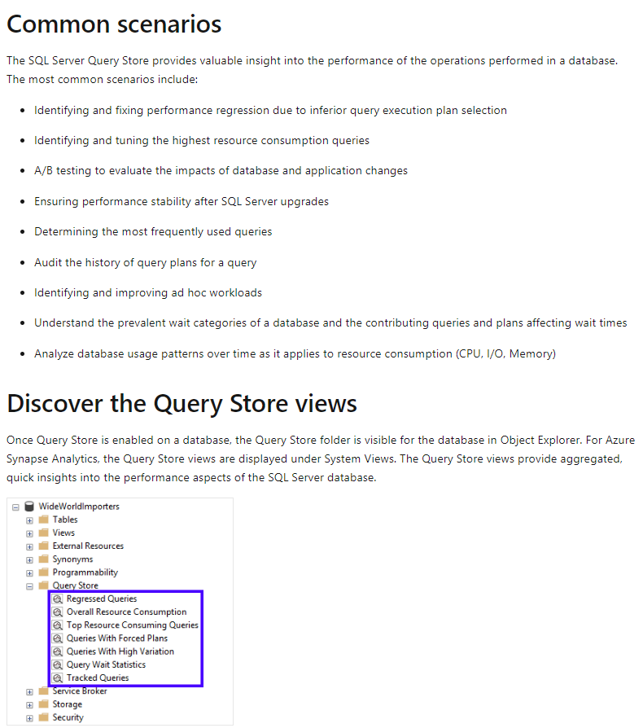

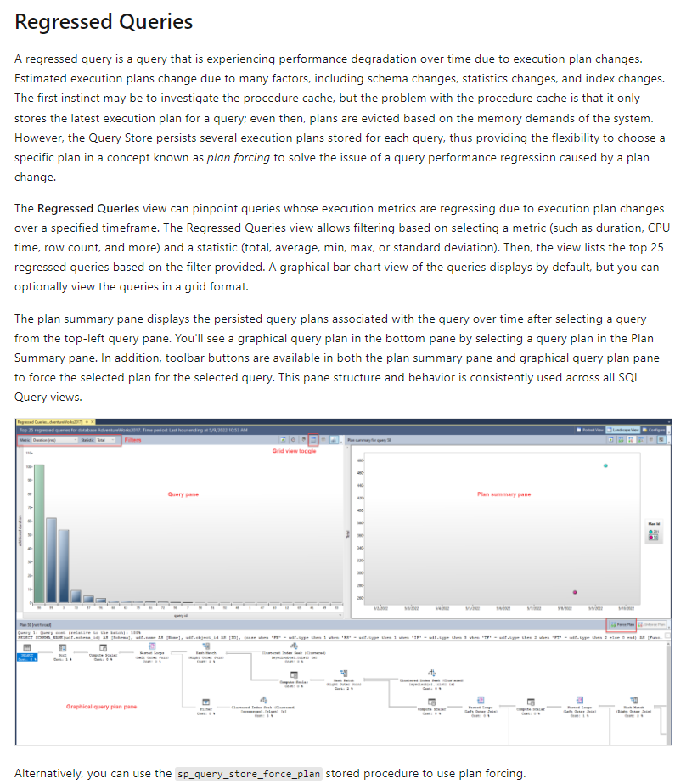

EXEC sp_query_store_force_plan @query_id=73, @plan_id=79

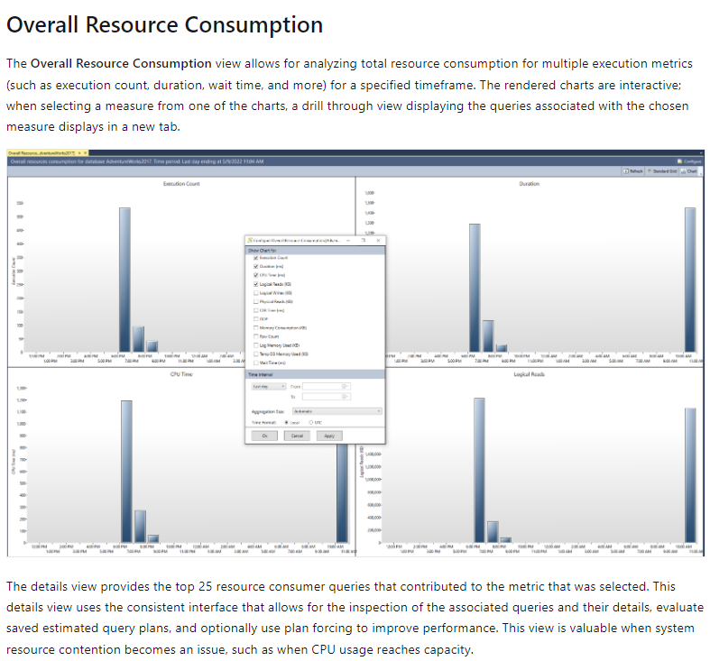

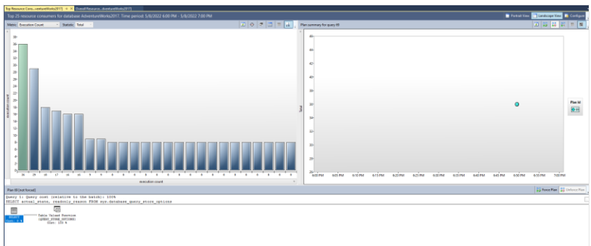

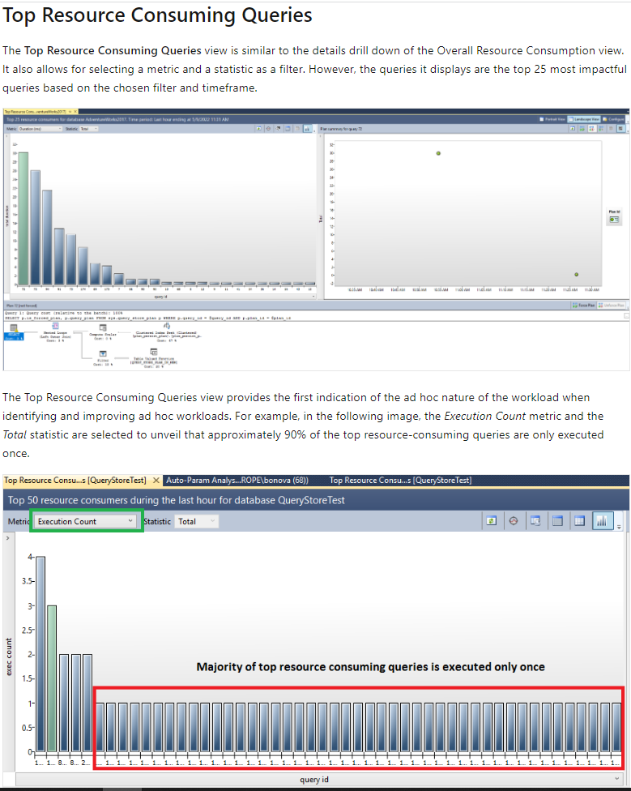

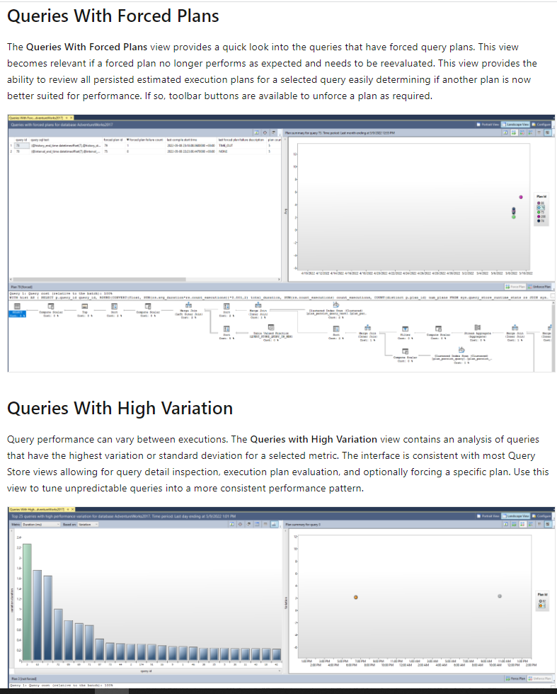

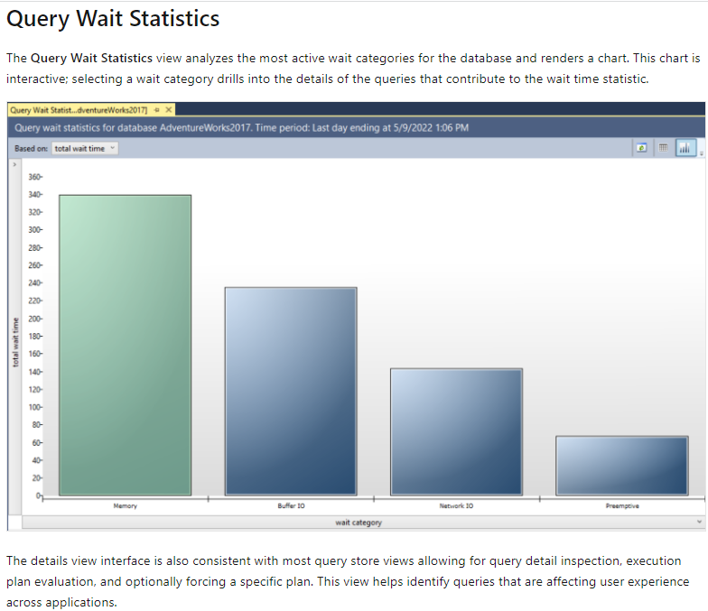

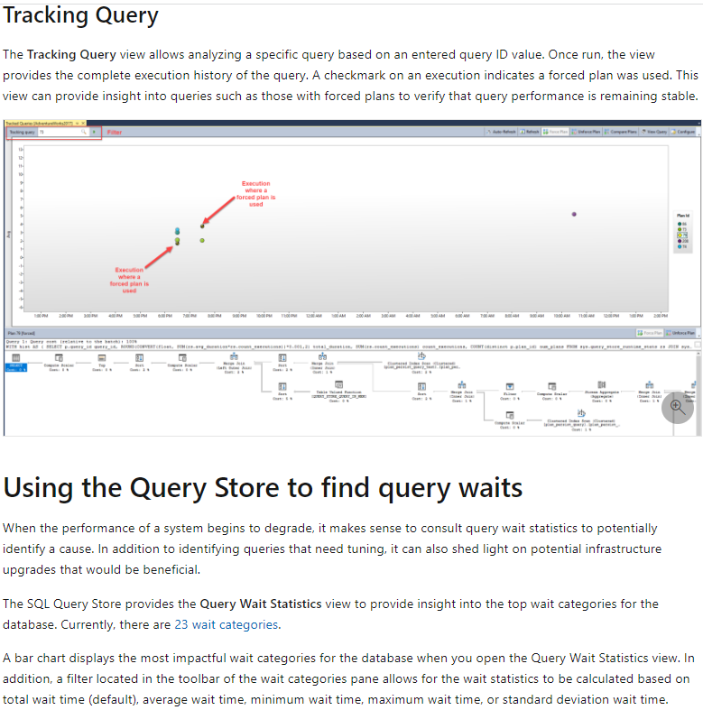

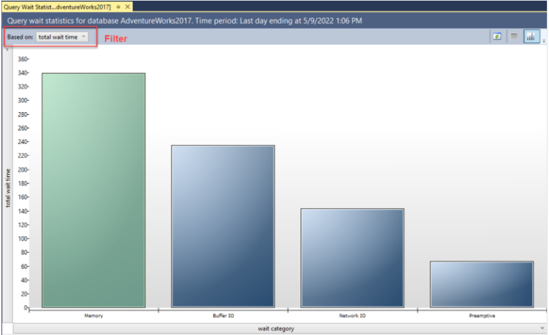

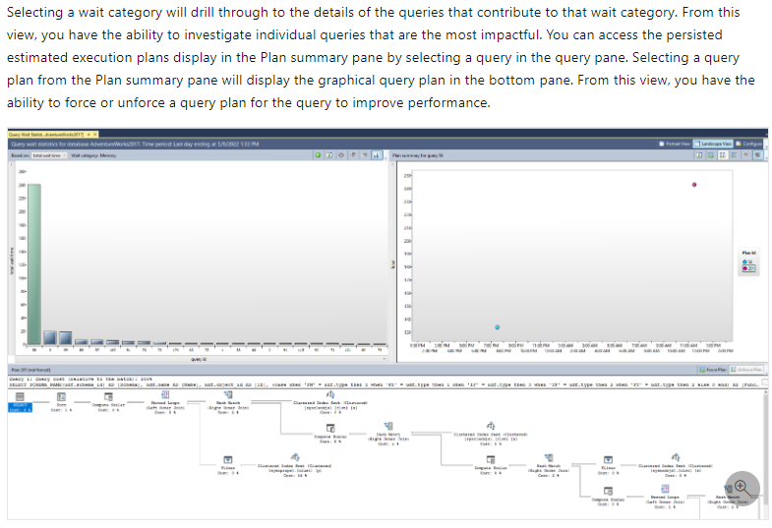

### U6. Identify problematic query plans

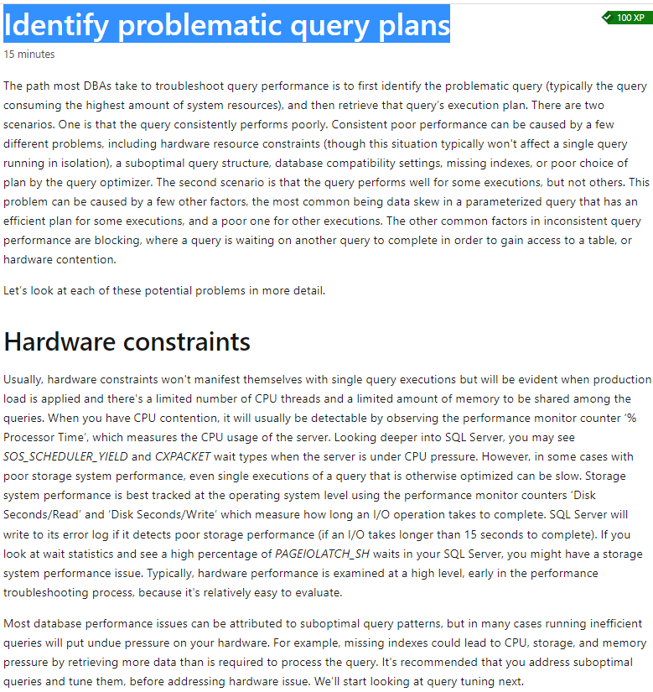

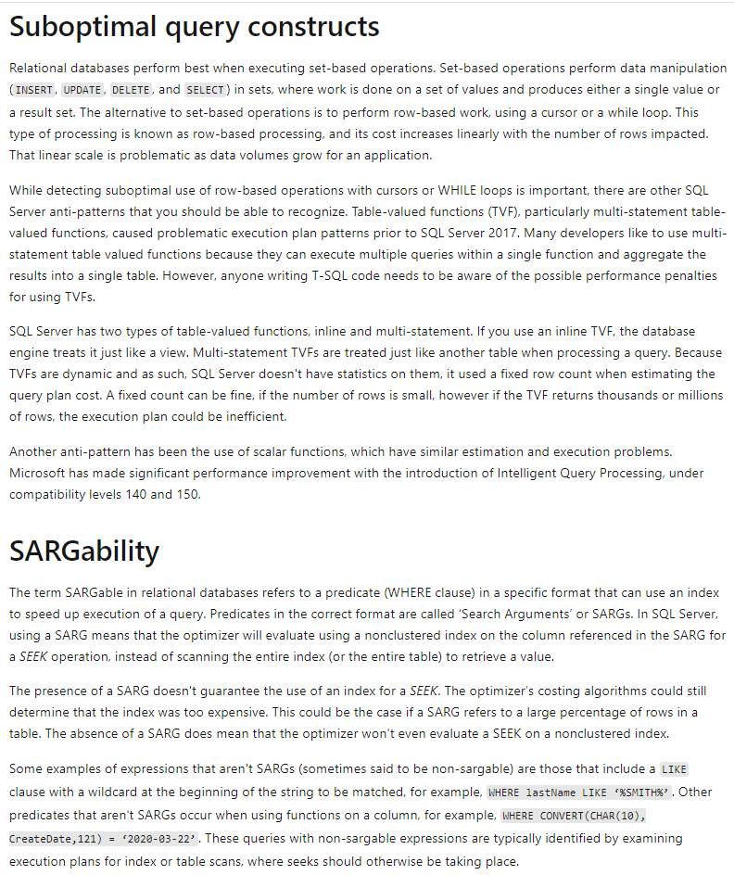

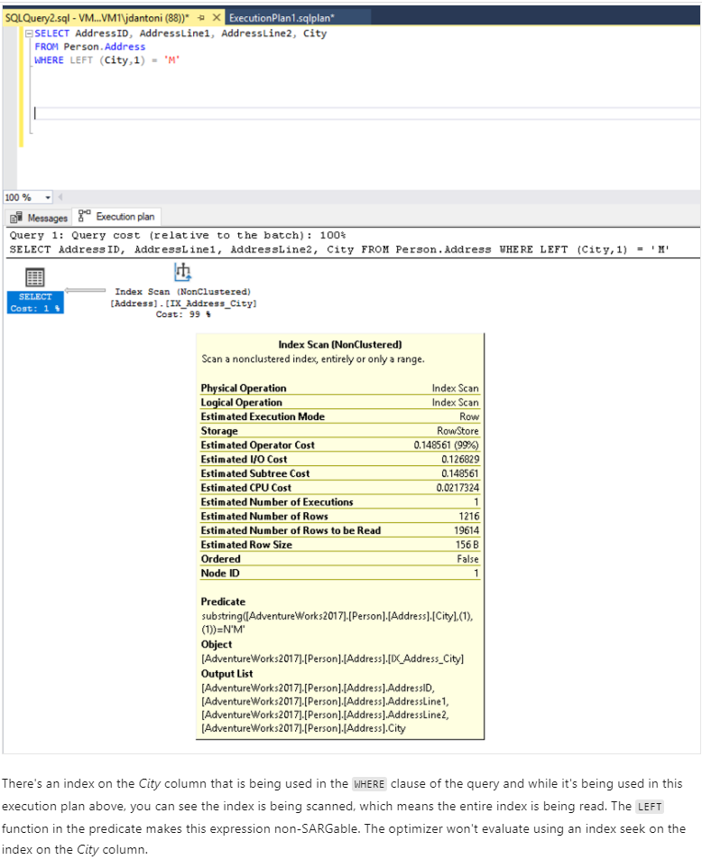



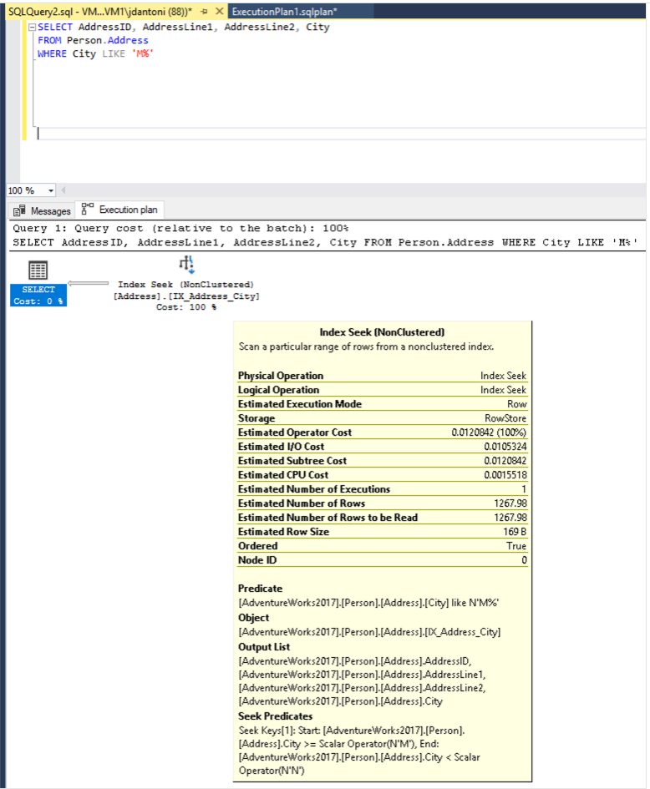

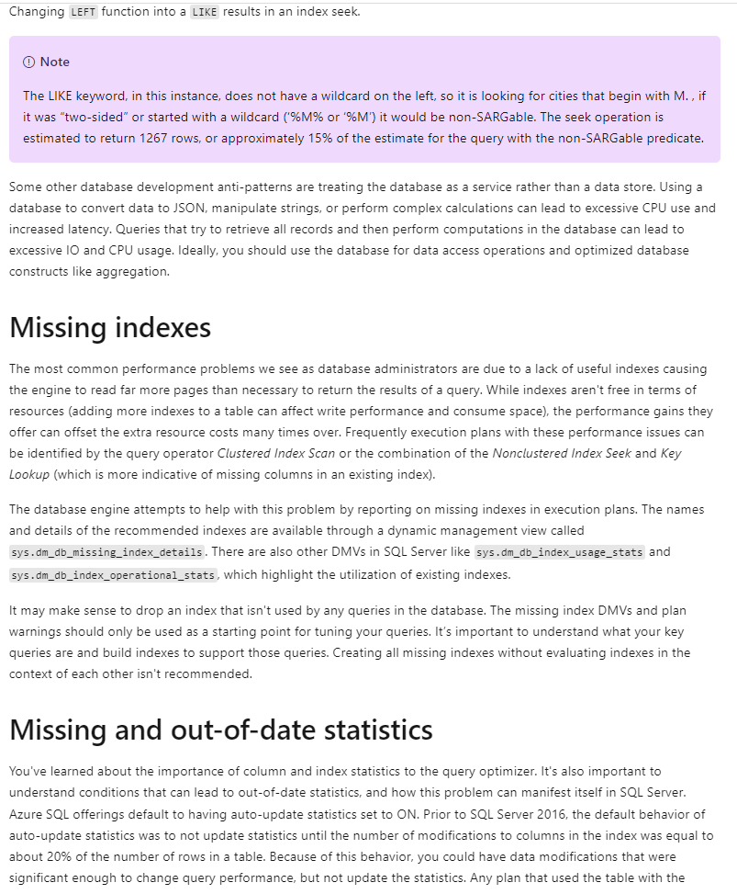

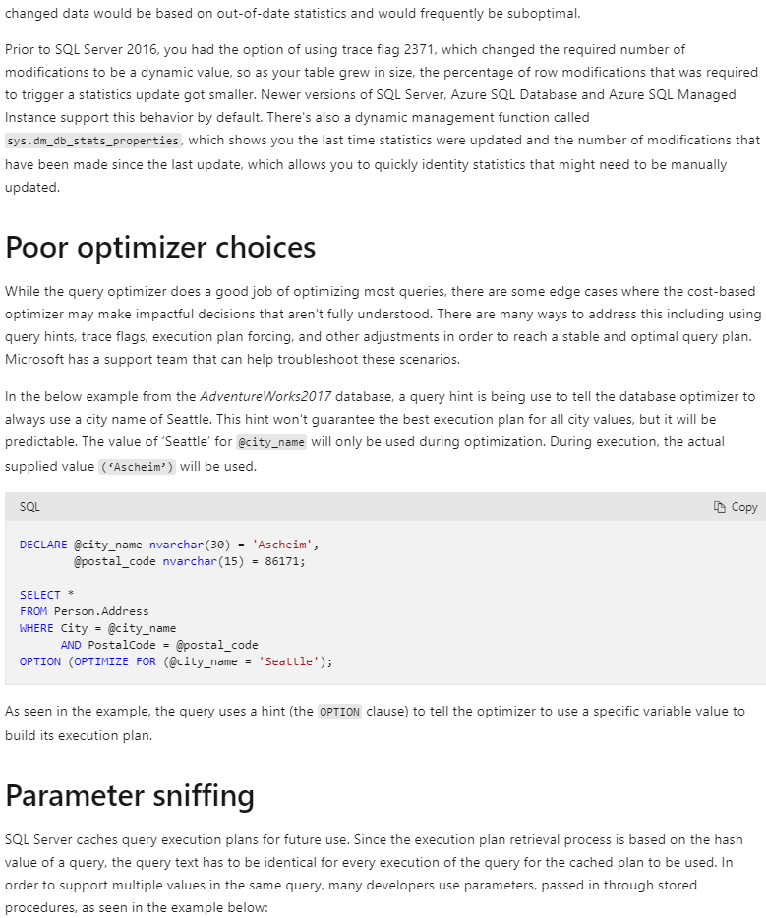

CREATE PROC GetAccountID (@Param INT)

AS

<other statements in procedure>

SELECT accountid FROM CustomerSales WHERE sales > @Param;

<other statements in procedure>

RETURN;

-- Call the procedure:

EXEC GetAccountID 42;

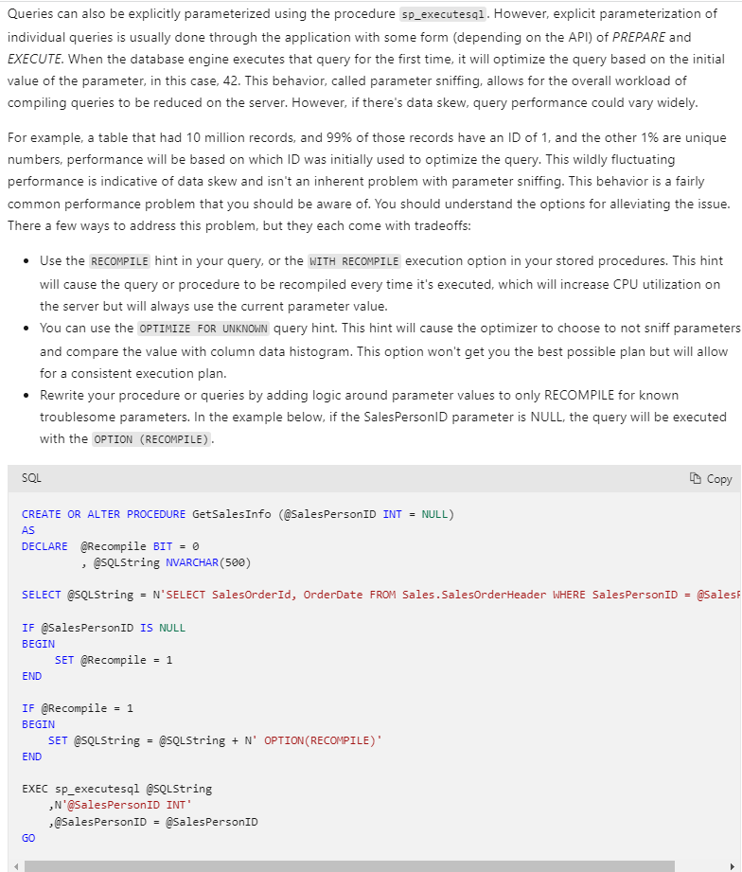



### U7. Describe blocking and locking

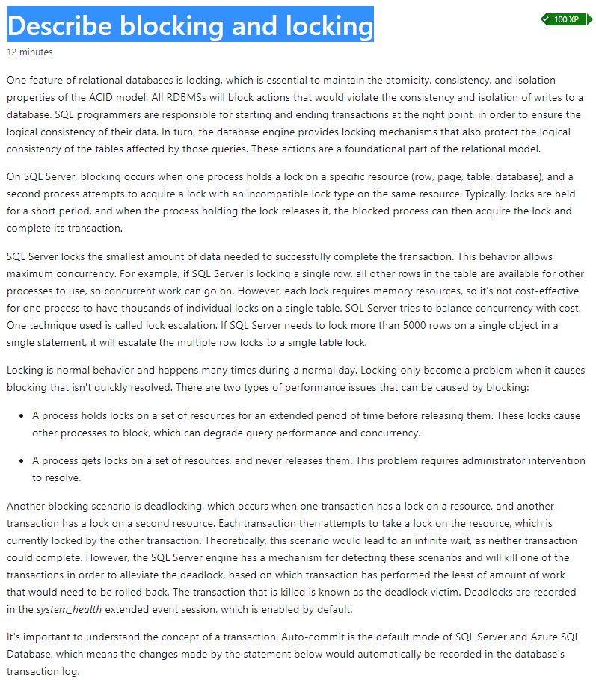

INSERT INTO DemoTable (A) VALUES (1);

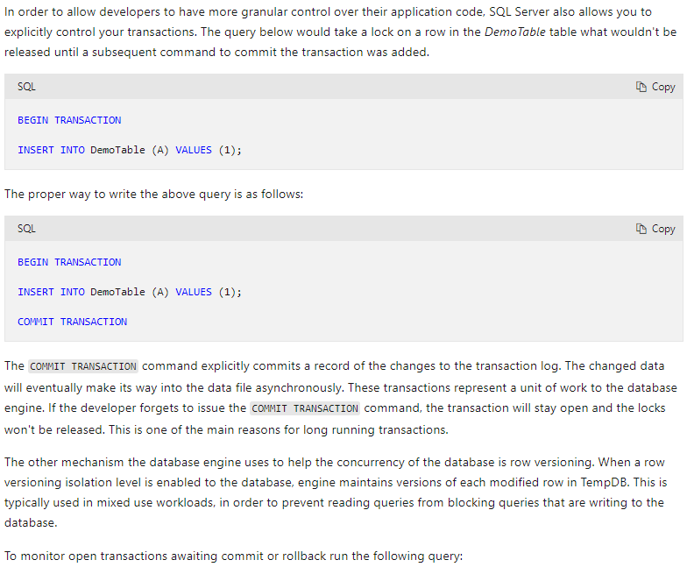

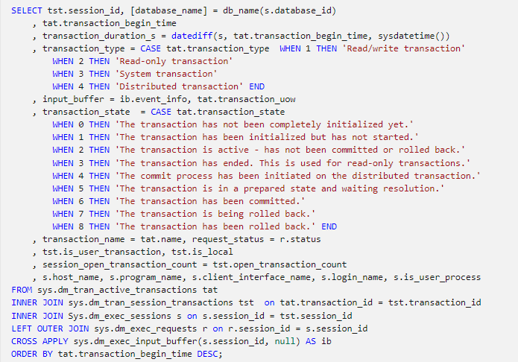

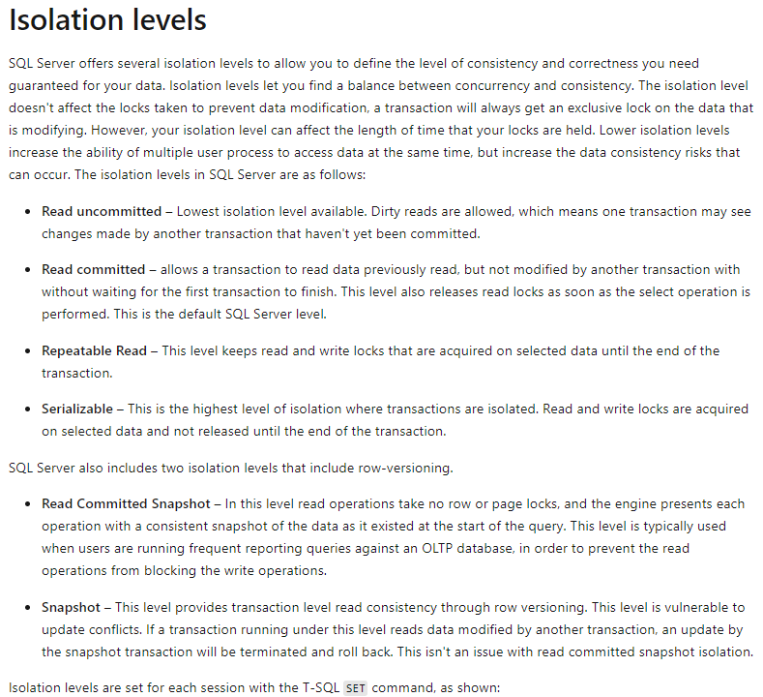

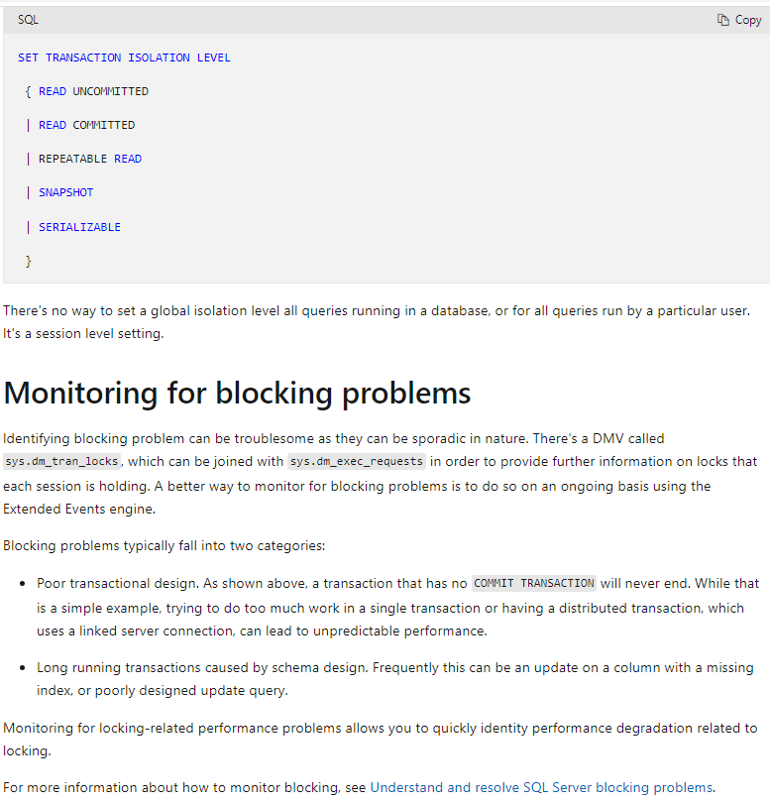

### U8. Knowledge check

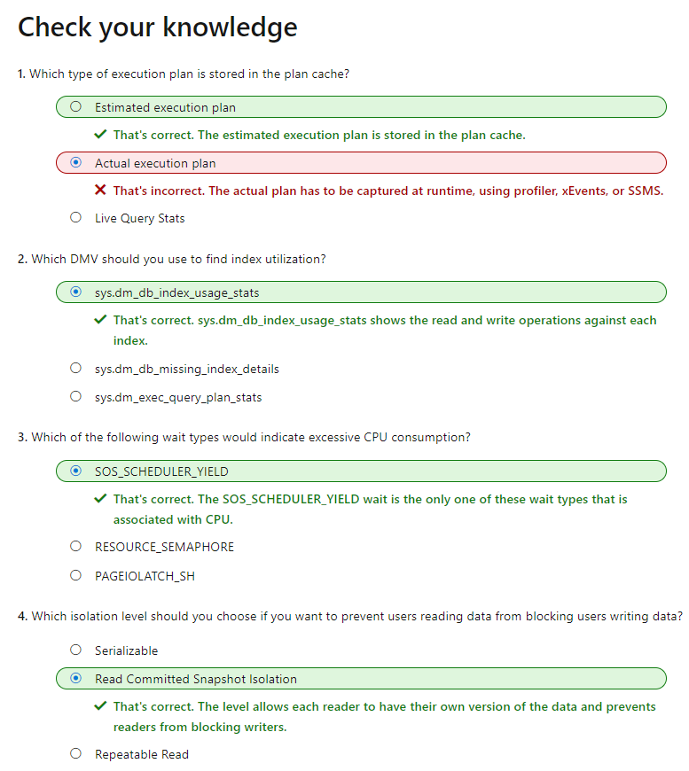

## M2. Explore performance-based design

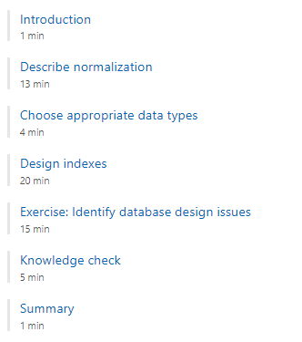

### U1. Introduction

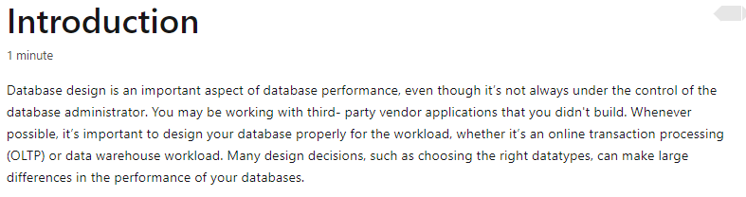

### U2. Describe normalization

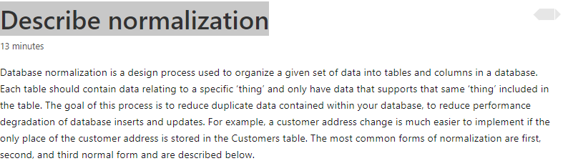

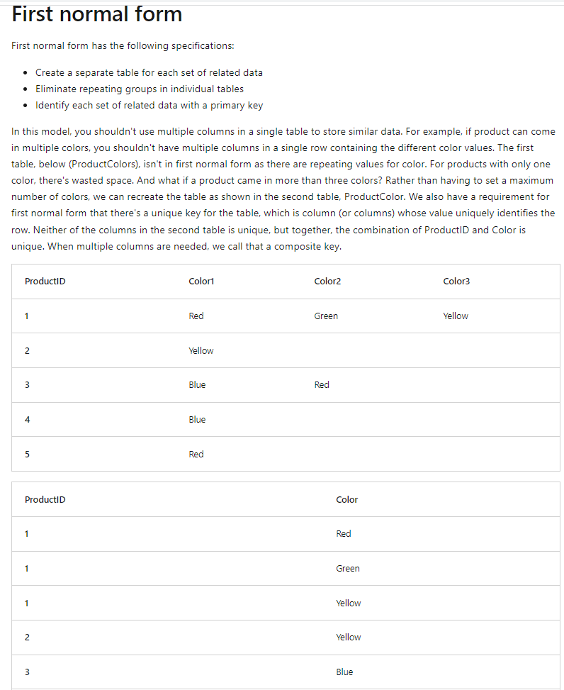



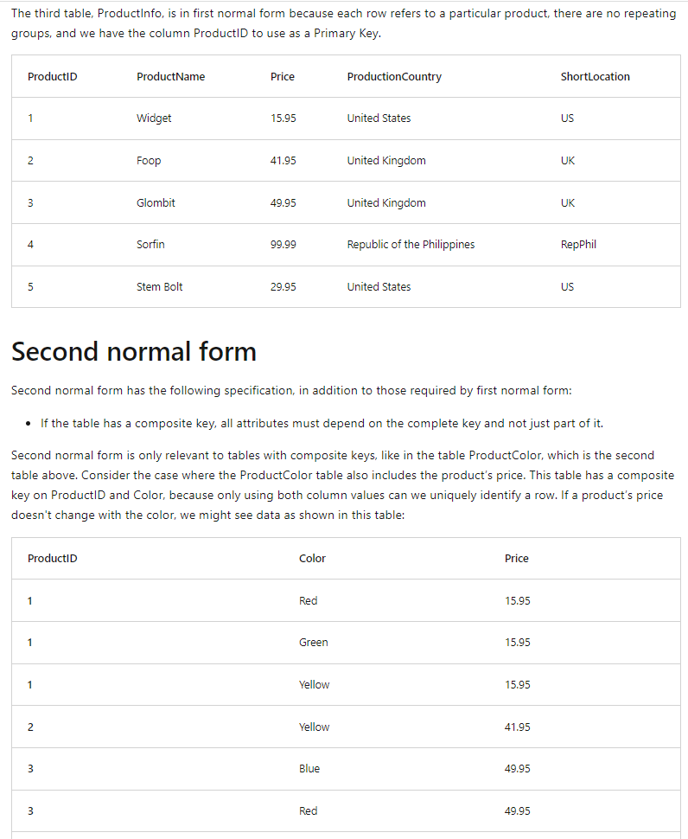



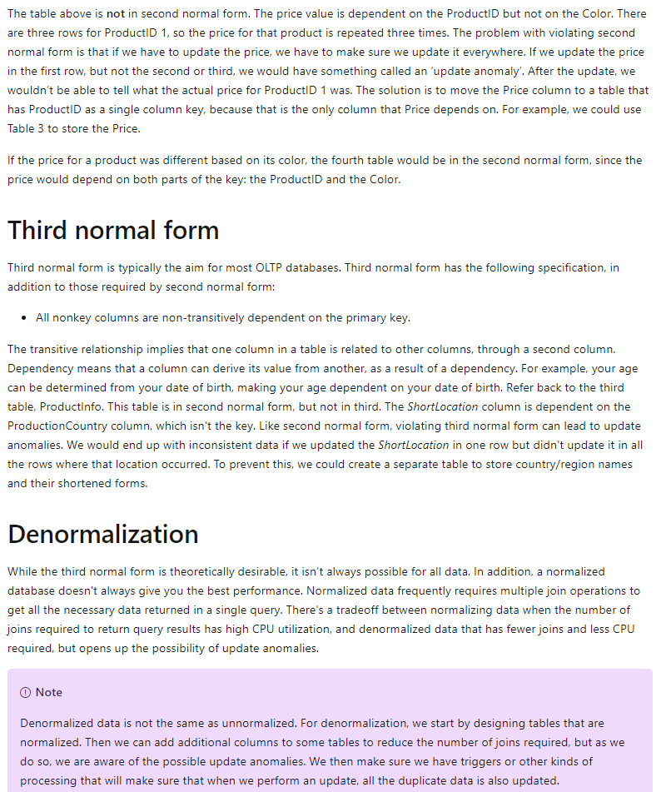



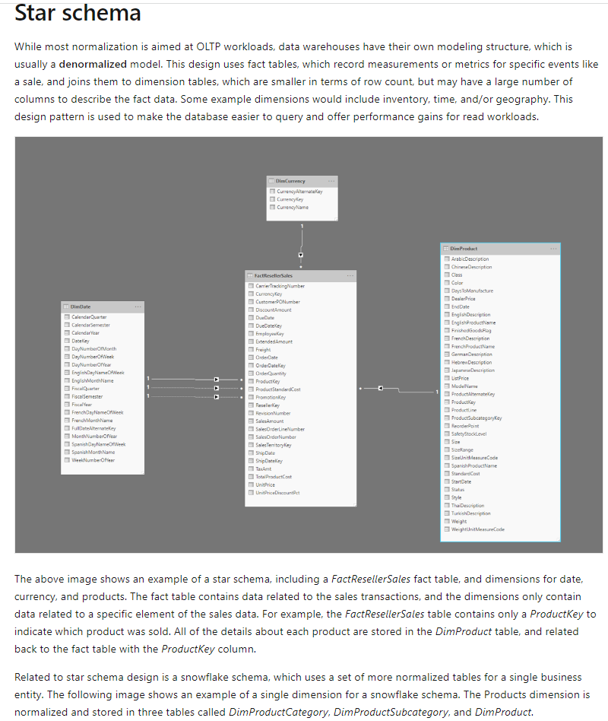

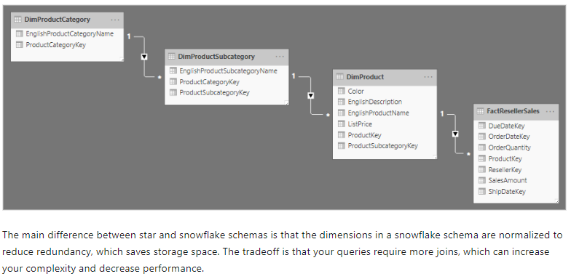

### U3. Choose appropriate data types

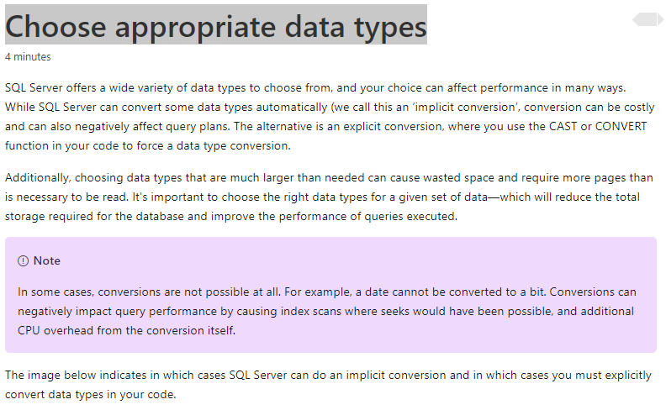

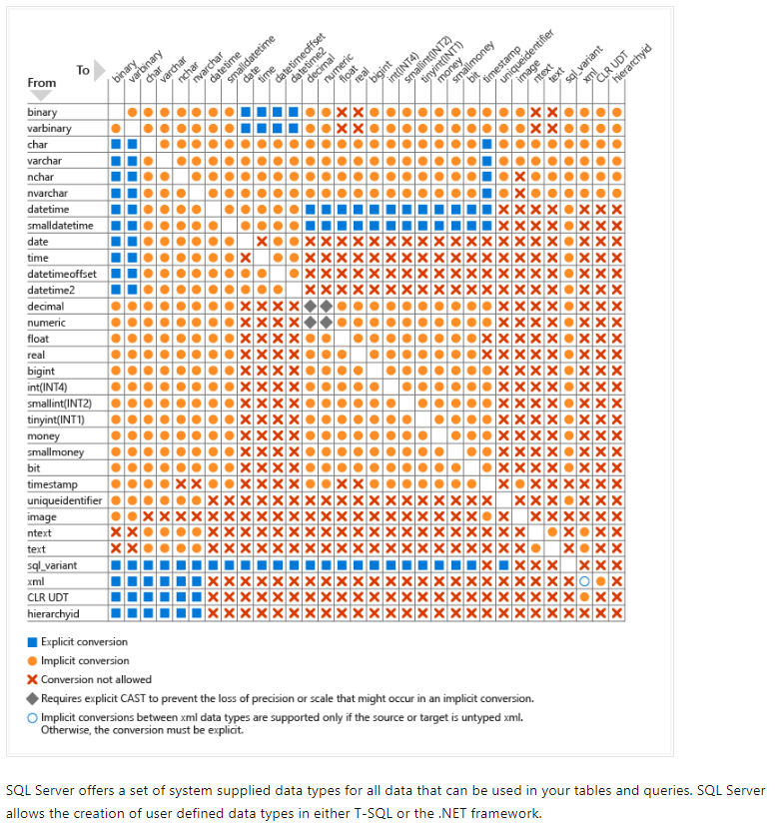

### U4. Design indexes

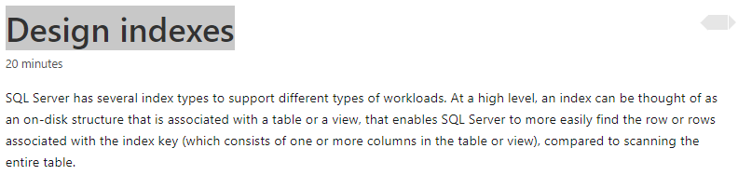

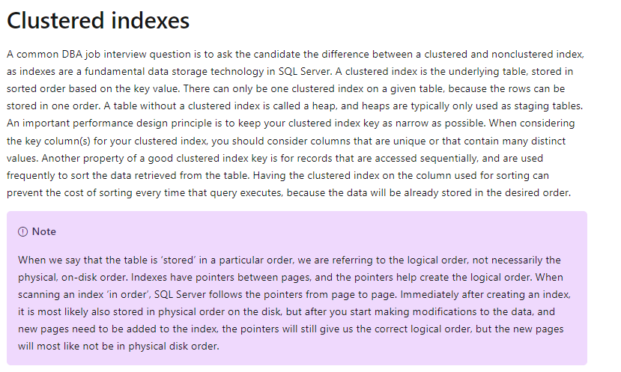

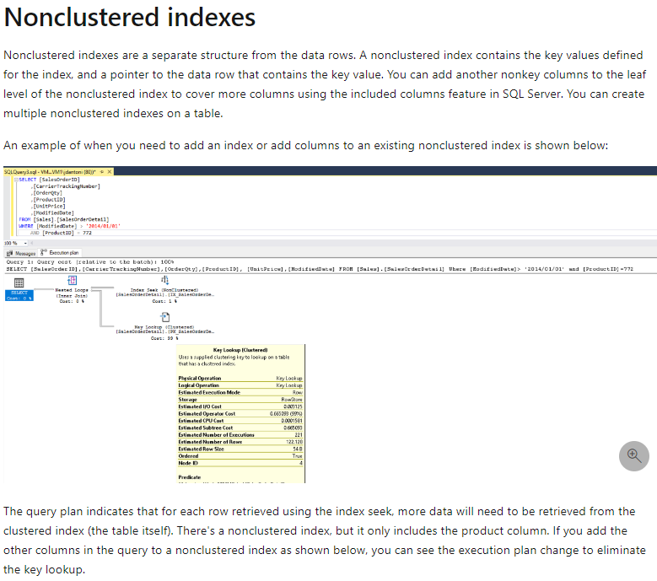

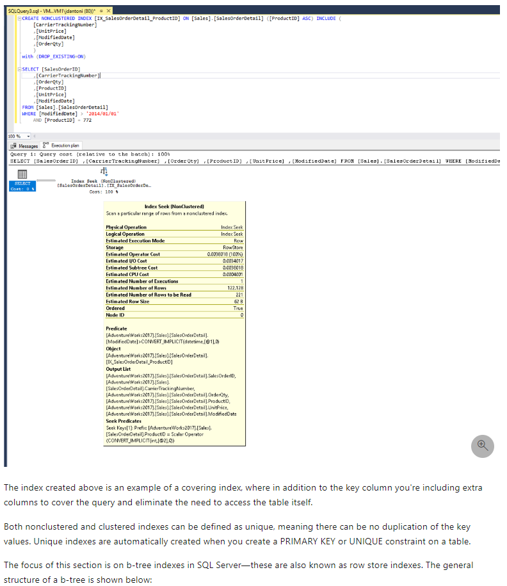

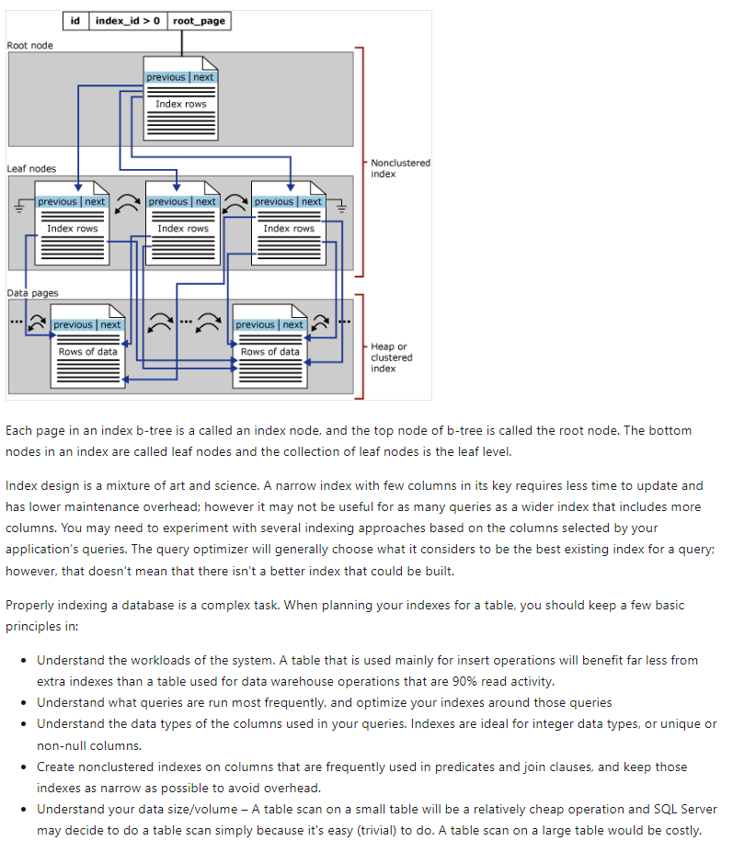

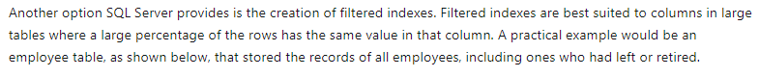

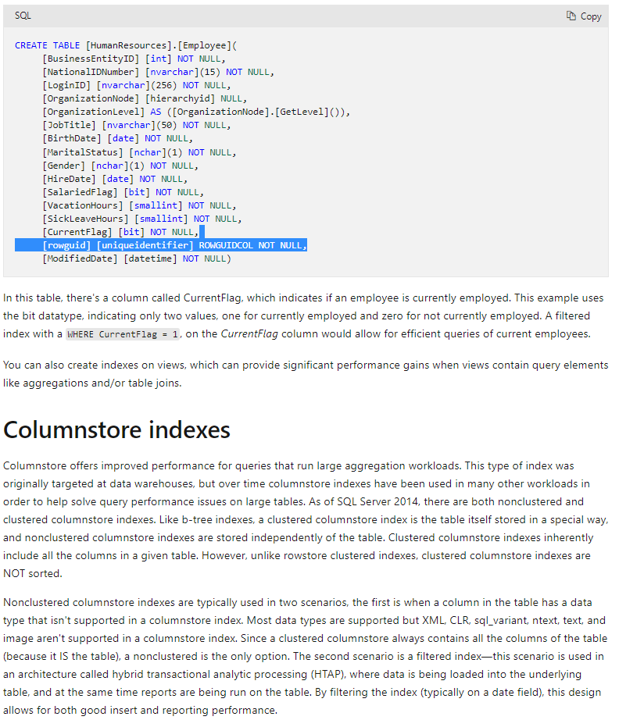

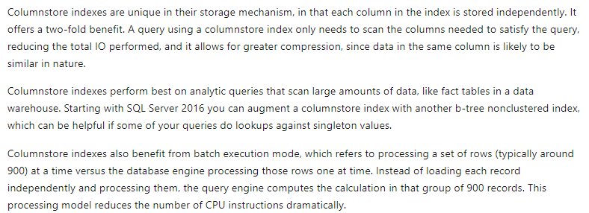

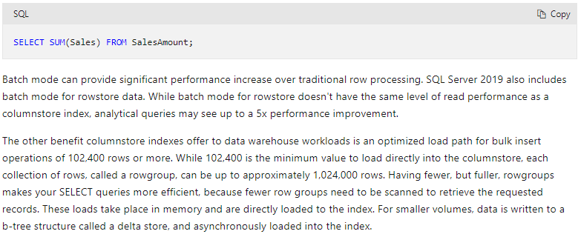

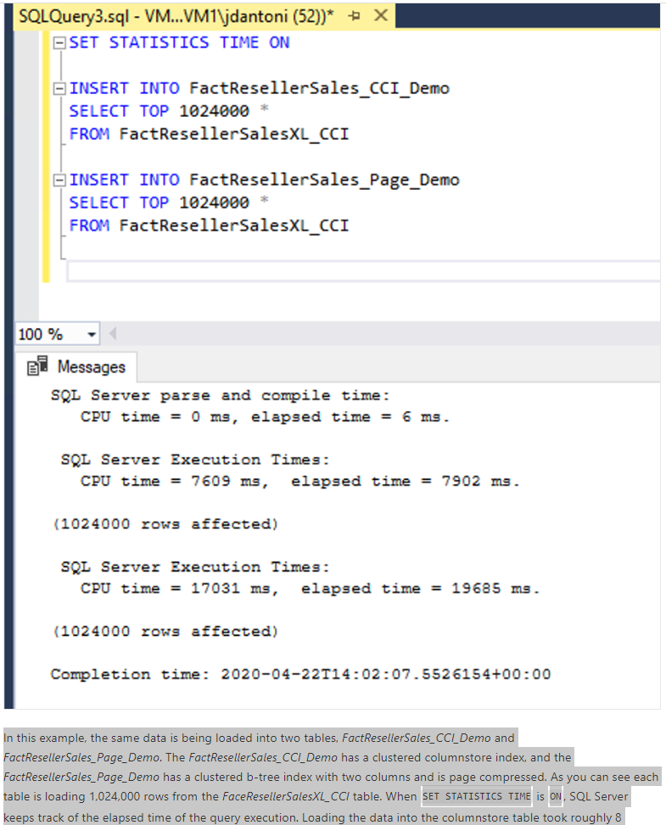

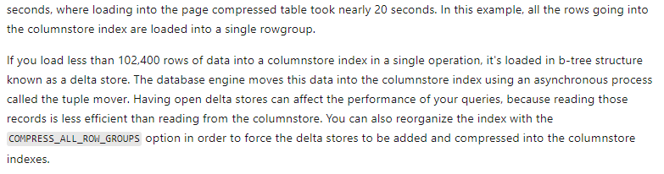

### U5. Knowledge check

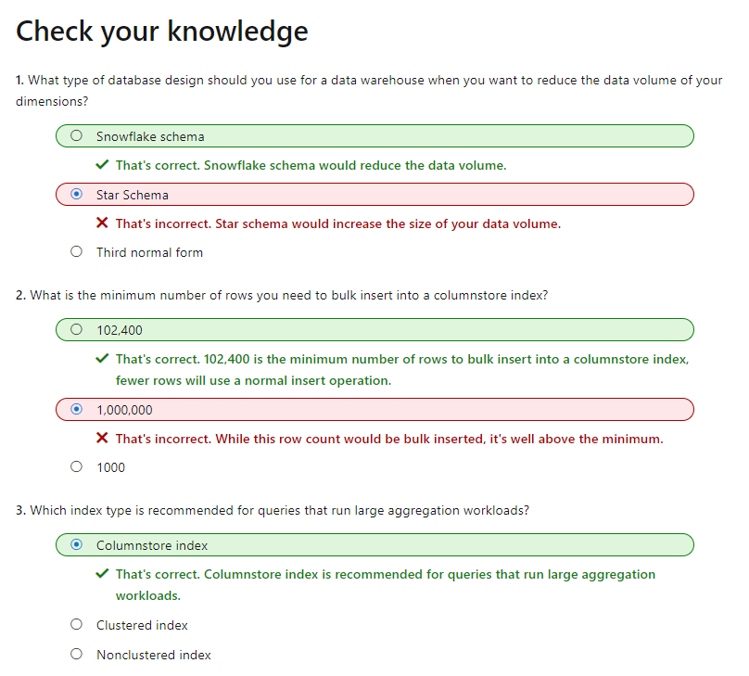

## M3. Evaluate performance improvements

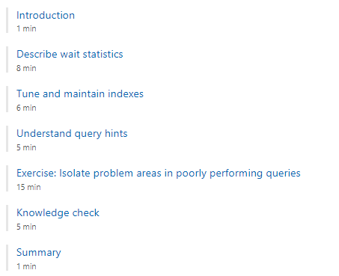

### U1. Introduction

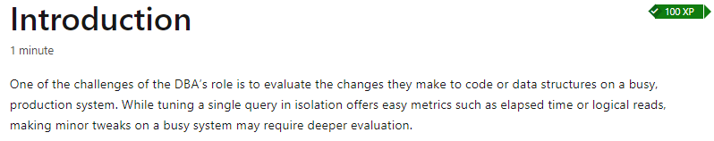

### U2. Describe wait statistics

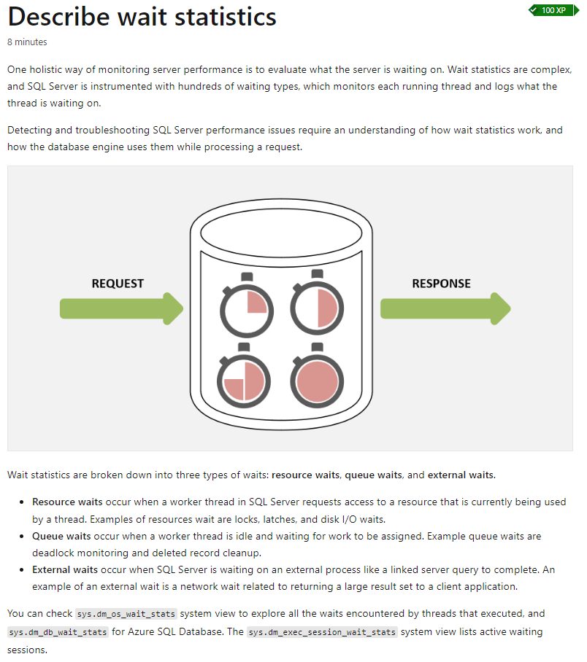

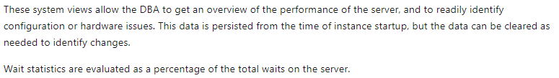

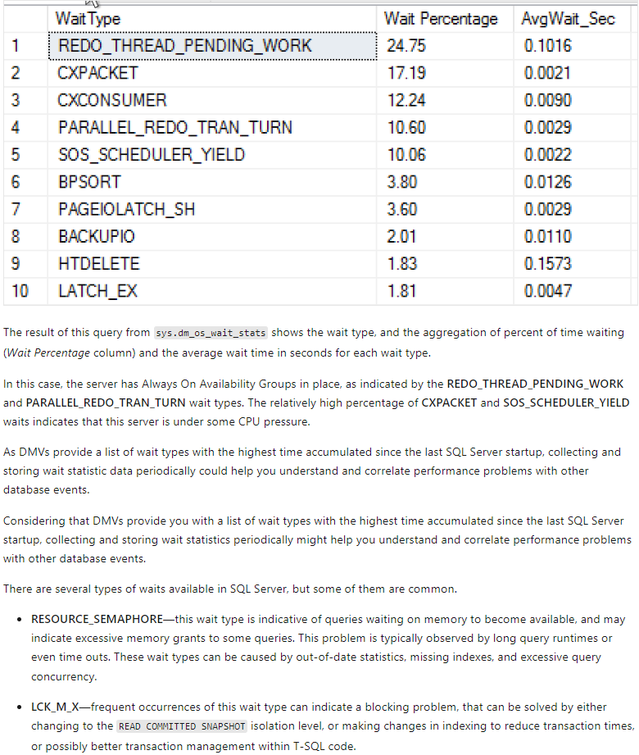

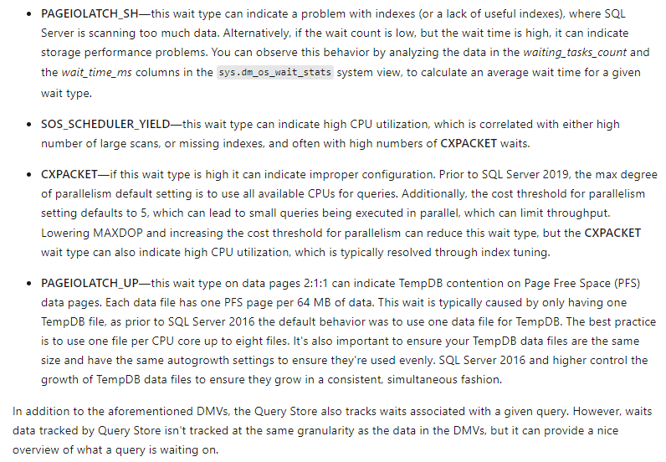

### U3. Tune and maintain indexes

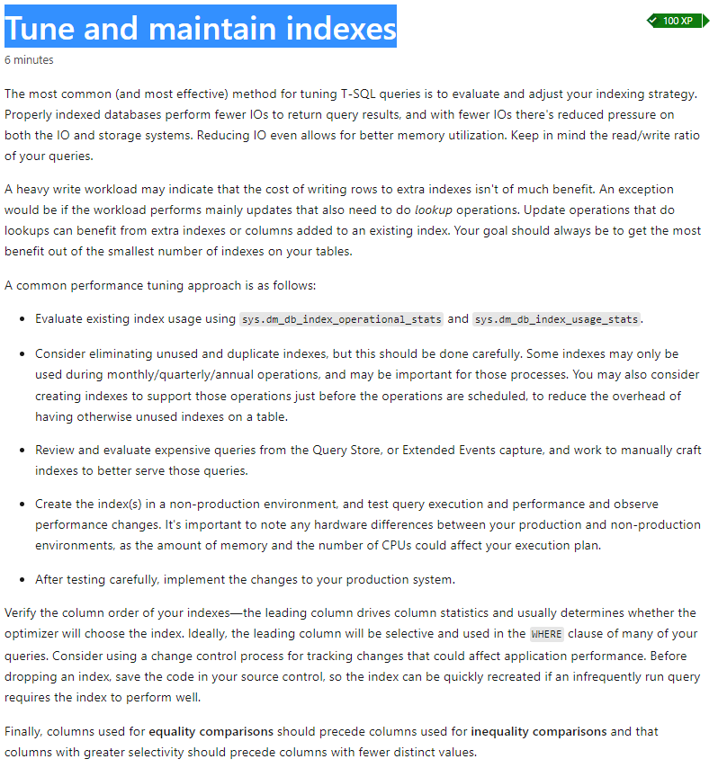

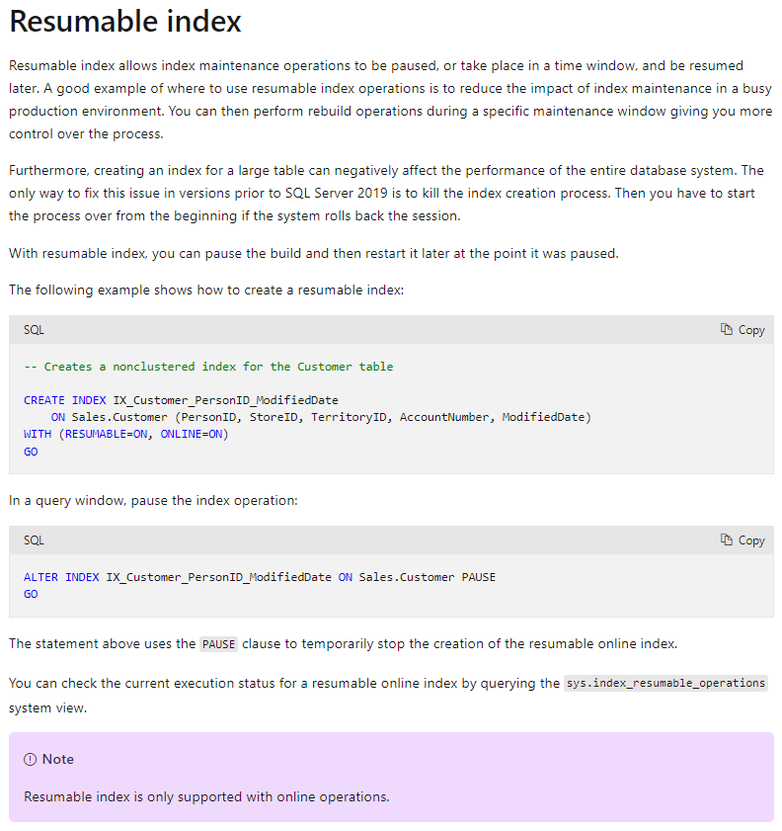

### U4. Understand query hints

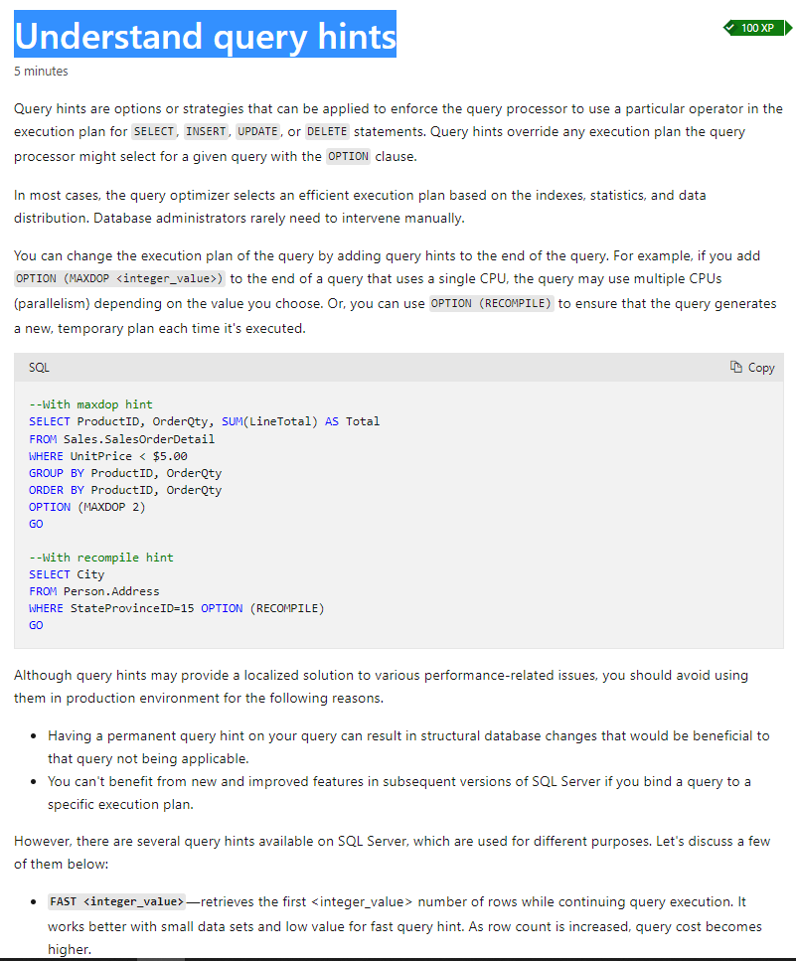

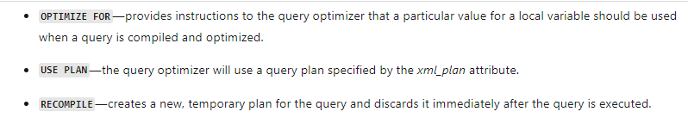

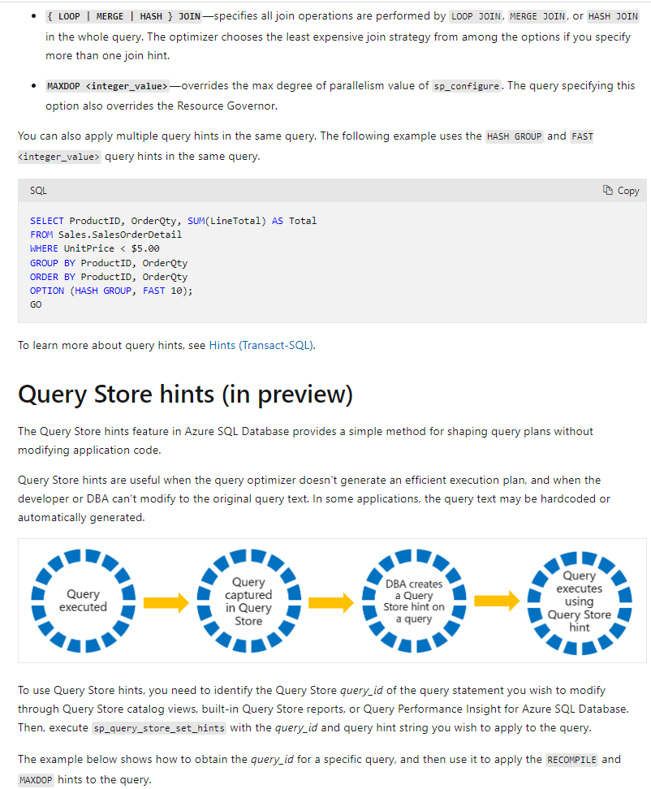

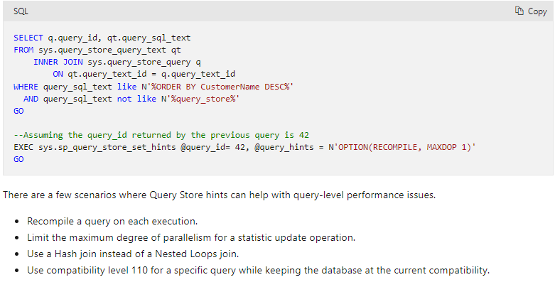

### U5. Knowledge Check

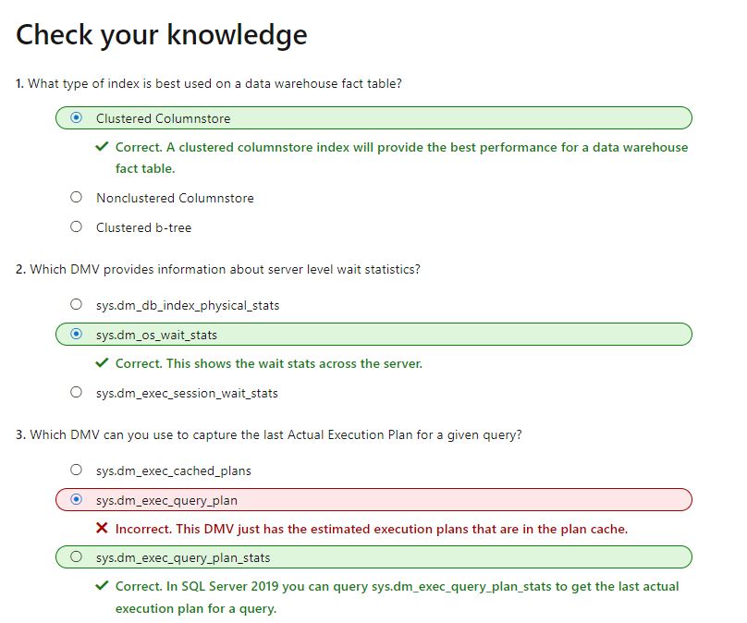

# LP6. Automate database tasks for Azure SQL

# LP7. Plan and implement a high availability and disaster recovery environment